Neuromod Toolbox
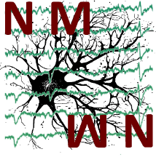
Fully Interactive Ephys Data Analysis
and Visualization for Matlab
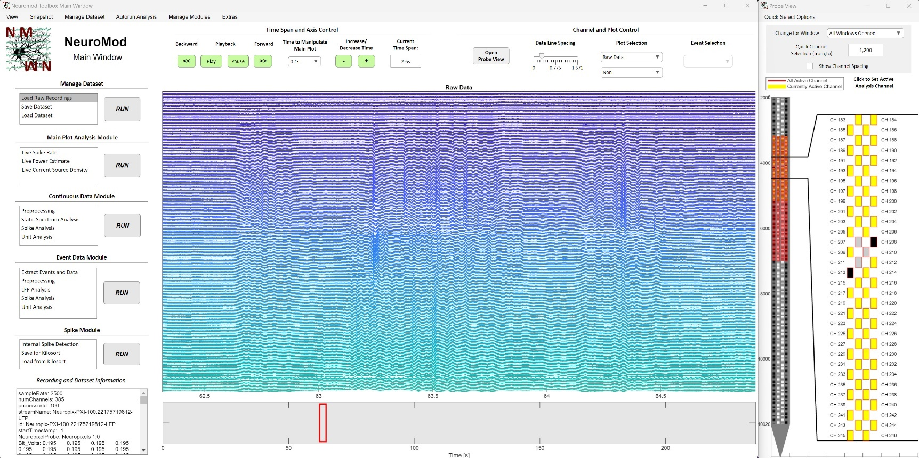

Contact: Tony de Schultz
Leibniz Institute for Neurobiology Magdeburg
Email: tony.schultz@lin-magdeburg.de

Content

1. General structure of the user interface 4
1.1 Data Structure: 4
2. Main Window: 5
2.1 Time Span and Axis Control Panel: 5
2.2 Channel Control and Plot Panel: 6
2.3 Recording Information Text Area: 6
2.4 Main Window Menu: 6
2.4.1. View: 7
2.4.2 Snapshot: 7
2.4.3 Manage Dataset: 7
2.4.4. Autorun Analysis: 7
2.4.5 Manage Modules: 8
2.4.6 Extras: 8
2.5 Probe View Window 9
3. Manage Dataset Module 10
3.1 Load Raw Recording: 10
3.2 Save Dataset: 14
3.3 Load Dataset: 15
4. Main Plot Analysis Module 15
4.1 Spike Rate: 16
4.2 Power Estimate: 17
4.3 Current Source Density: 17
5. Continuous Data Module 18
5.1 Preprocessing: 18
5.2. Band Power Analysis: 19
5.3. Continues Spike Analysis 20
5.4. Continues Unit Analysis: 22
6. Event Data Module 23
6.1. Extract Events and Data: 23
6.2. Preprocessing Event Related Data: 25
6.2.1. Trial Rejection: 25
6.2.2. Trial Rejection and Interpolation: 26
6.3. LFP Analysis: 26
6.3.1 Event Related Potential (ERP) Analysis: 27
6.3.2 Current Source Density (CSD) Analysis: 27
6.3.3 Static Spectrum Analysis: 28
6.3.4 Time Frequency Power Analysis: 28
6.4. Event Related Spike Analysis: 29
7. Spike Module 30
7.1. Spike Detection and Sorting: 30
7.2. Save for Spike Sorting: 33
7.3. Load Spike Sorting Results: 35
8. Autorun Function 36
8.1 Config File: 36
8.2. Autorun Manager Window: 39
9. Creating and adding your own Module 40
9.1. Manage Modules Window – Add you own Module: 42
9.2. Manage Modules Window – Activate your own Module: 43

1. General structure of the user interface

NeuroMod is divided into a range of different modules, each responsible for a different aspect of data analysis or general data management. The modules are listed on the left side of the main window and split into several different functionalities that can be executed by clicking on the respective name and the ‘RUN’ button. While data analysis has to be conducted in a certain general order of operations (extracting data, preprocessing, analysis, plot), the exact order and operation depends on the type of analysis. Therefore, every functionality of every module can be selected at any time, while some of them are dependent of each other. The order of modules listed on the left already suggests a general order what functionality can be used when, but this does not hold true for every analysis type. In doubt, clicking on an analysis without having executed the necessary steps before that will just open a message in Matlab, explaining what is missing.
The toolbox is designed in a way, that it holds a standardized data structure that can be easily accessed and understood. This means, you can create an extension of the toolbox with your own app window and full access to all data in just a few lines of code and a minute of work. The data structure will be shortly explained in the following as it will be referred to in the explanation of each individual module. After the module explanations, a more detailed description along with the possibilities to create your own app window and access the data structure will be given.

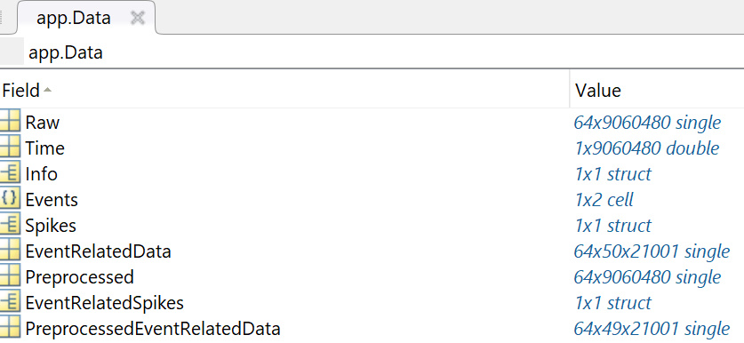
Data Structure:

Data Components accessible as app.Data. :
- Raw: Contains raw data extracted from your recording as a channel by time matrix.
- Time: Contains time points (in seconds) for each recording sample.
- Info: Structure containing the header information from your recording along with additional information about what was done to your recording (which preprocessing was applied, what events were loaded etc.). The contents can be seen in the recording information text area on the bottom left of the main window.
- Events: Cell array, where each cell holds a 1 x Nr. Events vector, saving the time points of each event/TTL signal to your recordings system (in samples). If you have two TTL streams to your recording system, this will be a 1x2 cell array.
- Spikes: Structure holding either the loaded spike sorting data or spike data from the internal spike detection. Spike times are saved as Data.Spikes.SpikeTimes in a vector. The information about which channel or depth the spike occurs is saved in Data.Spikes.SpikePositions vector with the same length. This holds true for all the other spike parameters, like cluster identity or amplitude. This means, spikes of a specific cluster, depth and/or ampitude can be easily accessed with logical indexing.
- EventRelatedData: Three-dimensional matrix with dimensions: channel x events x time. This saves your event related data.
- Preprocessed: Contains preprocessed data, with same dimensions as the raw data. This means, that each time you apply a new preprocessing pipeline, the old preprocessed data will be overwritten.
- EventRelatedSpikes: Structure holding either the loaded spike sorting data or spike data from the internal spike detection within the range of your event related data, to analyze event related spike activity (just some fields of the original Data.Spikes are used here). This is the only dataset component calculated ‘on the fly’ every time when you start an event related spike analysis window.
- PreprocessedEventRelatedData: Three-dimensional matrix with dimensions: channel x events x time. Event related data can further be preprocessed by deleting specific events, rejecting artefacts and/or rejecting channel. If you have 50 events in your recording and delete 2 trials, the EventRelatedData variable is a channel x 50 x time matrix, while PreprocessedEventRelatedData is a channel x 48 x time matrix.

Module Descriptions

2. Main Window:

The main window is the central hub that contains all the functionalities provided by the toolbox. The largest part of this window consists of two plots. The upper plot displays a data trace for each channel over a specified time window of your recording. The second plot below it shows the full time range of the recording, with a red rectangle indicating the time range shown in the plot above. By clicking on the time plot, you can jump to a specific time point, and the plot above will automatically update to show the data traces for the selected time.
To allow for more precise control over these plots, several panels are arranged around them.

2.1 Time Span and Axis Control Panel:
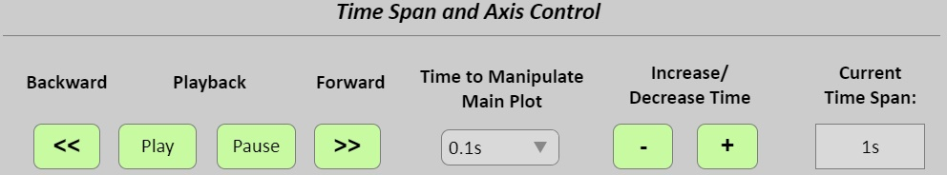

First, the time range displayed can be controlled using the panel on the upper right, called ‘Time Span and Axis Control’. In the center of this panel, you’ll find a dropdown menu labeled ‘Time to Manipulate Main Plot’. This dropdown indicates the amount of time the plot’s time range will be adjusted when you click the <<, >>, +, or – buttons. These buttons are used to jump forwards or backwards in time (<< and >>), or to increase/decrease the time range displayed ( + and – ).

The current time span being plotted can be adjusted by entering a value followed by an ‘s’ (for seconds) in the ‘Current Time Span’ field. Finally, you can view your dataset in movie mode by clicking the Play or Pause button. Pressing Play will automatically jump through time by a small increment (regardless of the setting in the middle) and update the data plot until you click Pause or the last time point is reached.

2.2 Channel Control and Plot Panel:

The second panel, named ‘Channel and Plot Control’, is used to control the main window data and time plot. The ‘Open Probe View’ button allows you to reopen the probe view window if it was closed.

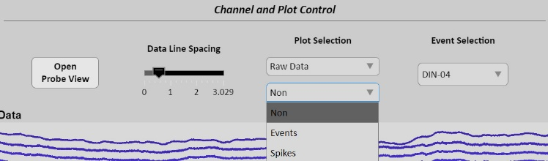
With the ‘Data Line Spacing’ setting, you can adjust the spacing between each data trace for a better overview of the scale. Right-clicking on the slider enables you to change the lower and upper limits.

The ‘Plot Selection’ dropdown menus control what data is displayed in the data plot. By default, you can view the data traces of your raw data. If you’ve preprocessed your data and want to see the results, you can select ‘Preprocessed Data’ from the upper dropdown menu to display the respective data traces. This option will appear only if your dataset has been preprocessed. You can switch between raw and preprocessed data at any time. The lower dropdown menu offers options to visualize additional aspects of your data. For instance, if your data contains events (such as TTLs indicating specific occurrences), you can extract the time points of those events and display them in both the data trace and time plot. The same applies to extracted spike time points. Enabling this feature will highlight the spikes by coloring the data traces at these time points in red, or it will show the exact time points with a red circle. The appearance of these markers can be adjusted in the main window menu under the ‘View’ menu.

Lastly, there is an ‘Event Channel’ dropdown menu where you can select which event (TTL) to visualize, in case your data contains more than one event.

2.3 Recording Information Text Area:

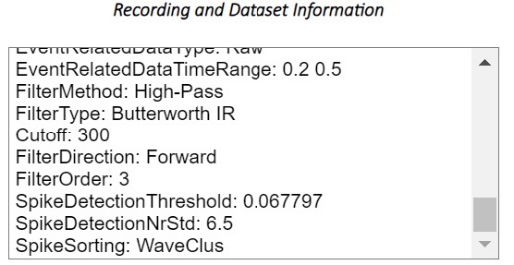
The text area in the lower-left corner of the main window displays all information about your recording stored in the app.Data.Info structure. This includes standard header information native to your recording system, as well as additional details such as the path from which the data was extracted, probe information, and a record of the operations performed on the dataset.

2.4 Main Window Menu:
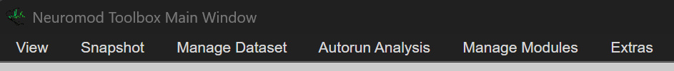
In the main window you have several additional options in the menu strip on top.

2.4.1. View:
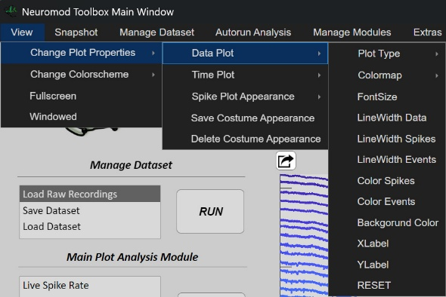
This menu offers customization options for the GUI window and plots. You can use it to switch between windowed and fullscreen modes, as well as adjust plot appearances. By default, plot appearances are changed temporarily, meaning they will reset to the standard settings when you reopen the GUI or load a new recording. However, you can save your customized appearance, which will then become the default appearance each time you restart the GUI. The ‘RESET’ option will reset only the plots in the main window (or the window where this option is available). The ‘Delete Custom Appearance’ option will reset all plot appearances to the standard settings and delete the custom appearance you saved earlier.

2.4.2 Snapshot:

Take a snapshot of the app window in the selected format.

2.4.3 Manage Dataset:

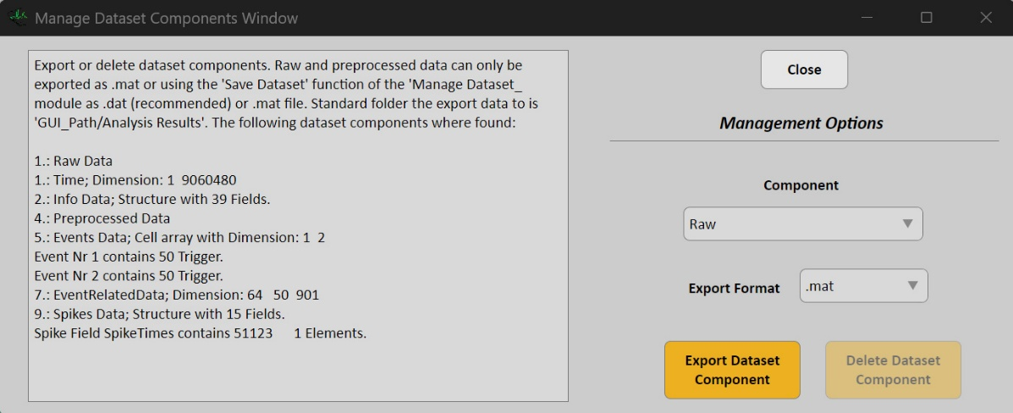
This opens a window where you can either delete a dataset component or export it in the selected format (.mat, .txt, or .csv). Some actions are only permitted on specific dataset components. For example, deleting raw data is not allowed. To properly export raw and preprocessed data, they can only be saved as a .mat file in this window, or as a .dat file (which is faster and more memory-efficient) through the ‘Save Dataset’ option in the Manage Dataset module.

2.4.4. Autorun Analysis:

Let’s say you have 20 recordings, and you want to run the same analysis pipeline on all of them. Instead of manually loading and clicking through each recording in the GUI one by one, you can use the autorun functionality to automatically loop through all recordings and apply your pipeline. This process depends on a configuration file, which contains a variable that stores all the parameters needed for the analysis in the GUI. You can modify these parameters as needed and choose between different config files and recording files in the window that opens when you click the "Autorun Analysis" menu. For a more detailed explanation, refer to the dedicated section on the autorun function.

2.4.5 Manage Modules:

Selecting this option opens the ‘Manage Modules’ window, where you can add your own module to the toolbox and modify the module selection options on the left side of the main window. Instructions on how to create your own module and app windows are provided later. In short, you can start by using the example saved in the folder ‘GUI_Path/Modules/Example Module - This Could Be Yours!’. The example module stored there can be added to the main window selection right out of the box. Simply add your own code and analysis to the example app window, adjust a few strings in a config file, and voilà – you’ve created your own extension to the toolbox. For a more detailed explanation, refer to the dedicated section on module management.

2.4.6 Extras:
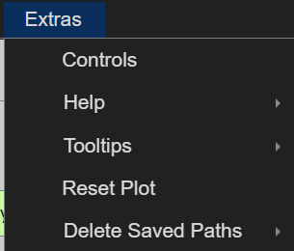
This section provides additional information and options for the GUI. Selecting ‘Controls’ opens a panel with basic details about the available options to control the GUI. The ‘Help’ option links directly to the GitHub page or this manual for further information. The ‘Tooltips’ option allows you to globally turn tooltips on or off for every window. The current state (on or off) can also be saved for the next startup of the GUI. Lastly, ‘Reset Plot’ lets you reset the main window’s data and time plots.

2.5 Probe View Window

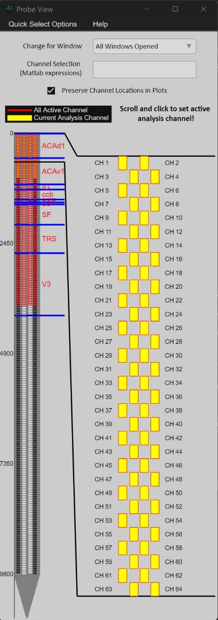
This window is the primary way to interactively select the channels shown in both the main and analysis windows of the GUI. It opens automatically when a new recording or saved data is successfully loaded.
On the left, a generalized probe design is displayed, showing all specified channels. Active channels (those with recorded data) are outlined in red. In this example, every channel is active, but you can design probes with inactive channels interspersed or placed above/below the active ones. Channels currently viewed for analysis are highlighted in yellow, while channels not shown in the analysis are filled with black or white for distinction. These colors help differentiate between active channels.
From the probe view on the left, a black bracket extends to the right, providing a zoomed-in view of the channels within the selected bracket. This zoomed-in view allows you to activate or deactivate channels for analysis by clicking on them. Larger rectangles may be needed for probes with a high channel density. The zoomed-in view also enables channel numbers to be displayed. You can change the portion of the probe viewed in the zoomed-in area by clicking anywhere within the plot or by scrolling with the mouse wheel while hovering over it.
In this example, probe positions relative to a mouse brain were created using the Trajectory Explorer Toolbox and loaded via the ‘Extract Data’ window. Brain area borders can be assigned to probe depths, helping to identify which brain areas the analysis channels correspond to.
Above the interactive probe plot, a few additional options are available. The ‘Change for Window’ dropdown menu allows you to select the window to which the current channel changes will be applied. This is useful when multiple analysis windows are open, as updating all windows simultaneously can be time-consuming. Below this, the ‘Quick Channel Selection’ field enables the selection of a range of channels, formatted as two numbers separated by a comma (e.g., 1,10 to activate channels 1 to 10, if they are part of the active channels). The ‘Show Channel Spacing’ checkbox adds spacing between channels, visually resembling the appearance of the actual probe, but this is purely cosmetic. Finally, the ‘Quick Select Options’ menu at the top-left allows for quickly activating subsets of the probe's channels.
Note: Even if channels are adjacent in the probe design, they are plotted from top to bottom in the analysis windows. The first data row plotted corresponds to the topmost active channel. In the example above, channel 1 is plotted first, followed by channel 2, then channel 3, and so on. If channel names are reversed, the first plotted data channel will be channel 384, followed by channel 383, and so forth. In MATLAB, the topmost channel in the probe design is plotted first, corresponding to the first row in the Data matrix (nchannel x ntime). The next channel (depending on whether the channel names are reversed) is plotted as the next row in the Data matrix, and so on.

3. Manage Dataset Module
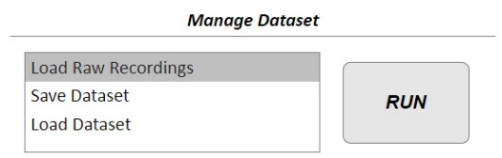
This module contains all functionalities to load a new recording, save the current dataset or load a previously saved dataset. Each functionality is explained separately:

3.1 Load Raw Recording:

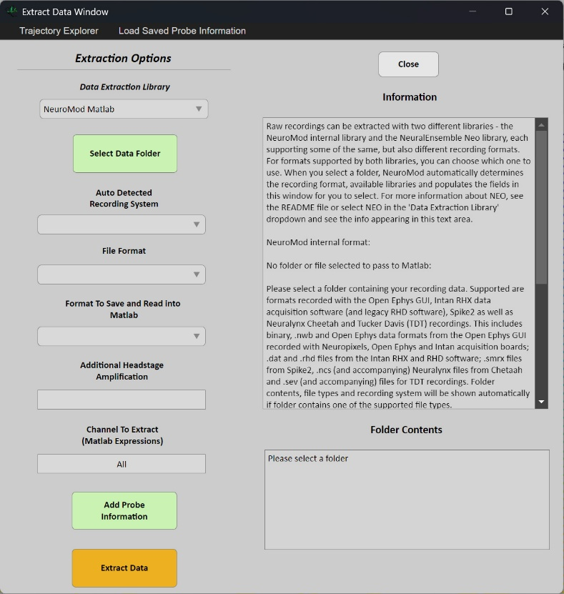
This app window allows you to extract raw data from your recording. It supports formats recorded with the Open Ephys GUI, Intan RHX data acquisition software (and legacy RHD software) as well as Spike2 and Cheetah software. This includes binary, .nwb and Open Ephys data formats from the Open Ephys GUI recorded with Neuropixels - and Intan acquisition boards; .dat and .rhd files from the Intan RHX and RHD software; .smrx files for Spike2 and .ncs for Neuralynx Cheetah files.
To extract data from a new recording, you first need to select a folder containing your recording using the ‘Select Data Folder’ button. Note: The folder should contain only one recording. For multiple recordings, use the Autorun functionality. When loading Open Ephys data, ensure the folder contains the ‘Record Node’ folder, which is natively created by the Open Ephys GUI.
When you select a folder, the system automatically checks whether it contains a supported data format and if all expected files are present. If a suitable recording is found, the folder contents will appear in the upper text area of this window (as shown in the example with Intan recording files). Additionally, the recording system and file type information are auto-filled. While you cannot edit the recording system dropdown (since it's autodetected), you can use the File Type Dropdown menu for Open Ephys recordings to select the specific recording node from which you want to extract data.
If no suitable recording is found, you will be notified in the upper text area.
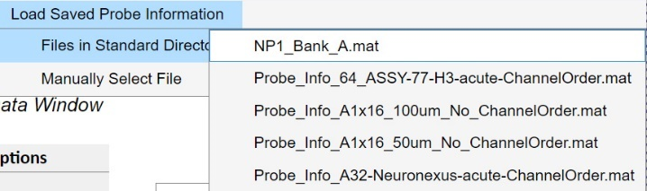
When extracting your data, it is automatically converted into mV based on the A/D bit conversion values obtained from the original recording headers. However, if there are additional signal amplifications in your system that are not saved in the recording header, you can specify these amplifications in the ‘Additional Amplification Factors’ text field. field. If non empty, your recording data will be multiplied by this factor to account for the additional amplification.
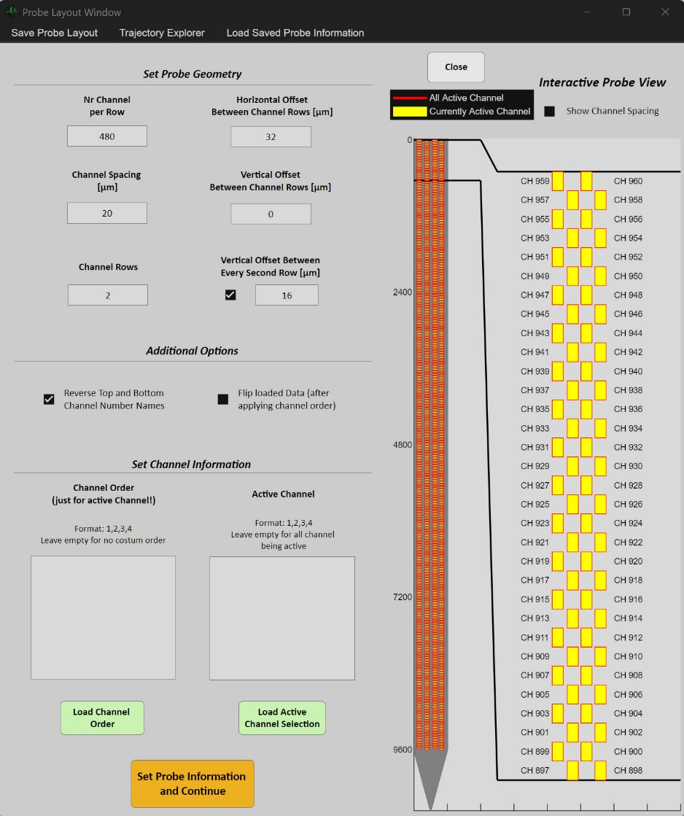
At the top of the window, additional menus are available. Firstly, the ‘Trajectory Explorer’ menu lets you either start the Neuropixels trajectory explorer or load a trajectory exported from it. For this to work, you need to download a mouse brain atlas from the Allen Institute (Link: https://osf.io/fv7ed/) and place it in its own folder within the Neuromod main folder (so it’s part of the path when starting the GUI). After setting your probe position, save the coordinates using the save menu in the trajectory explorer. You can then load these coordinates using the second option in the ‘Trajectory Explorer’ menu.
Secondly, you can select the ‘Load Saved Probe Information’ menu to quickly load probe designs that were saved earlier. This menu searches the folder ‘GUI_Path/Probe Layouts/Saved Probe Layouts’ for .mat files containing probe designs. If such files are found, they will appear as options in this menu. Therefore, when saving new probe designs, ensure they are stored in this folder to make them accessible here. Alternatively, you can select ‘Manually Select File’ if the probe design is located in a different folder.
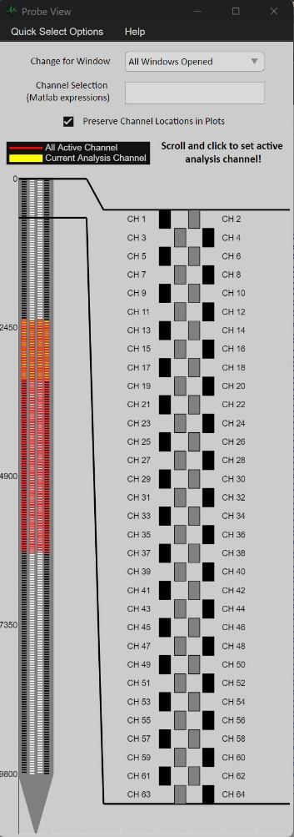
The next step is to specify your Probe Layout, which can be done by clicking the ‘Add Probe Information’ button in the ‘Extract Data’ window. This opens a separate window for the ‘Set Probe Geometry’ panel. On the left side, you can specify the number of channels per channel row, the number of channel rows, and the channel spacing (in micrometers). For example, with a Neuropixels probe that has 384 channels and 2 rows, you would set 192 channels per row.
On the right side of the panel, you can specify the horizontal distance between channel rows and an additional vertical offset. The vertical offset shifts the second channel row by the specified distance in micrometers. If you need every second channel row (i.e., channel 3, 4, 7, 8, 11, 12, etc.) to be offset from the other rows, you can activate the ‘Vertical Offset Between Channel Rows’ checkbox and specify the offset in the corresponding field. If unsure, feel free to experiment with the settings, as the changes will be visible in the probe design on the right.
NOTE: Changing the horizontal offset and offset for every second row does not adjust the probe design, as the plot is not scaled to these parameters. However, these values are still important for creating accurate probe designs for spike sorting.
In the ‘Additional Options’ panel, you have a few more options to specify the probe design:
Activating the ‘Reverse Top and Bottom Channel Number Names’ checkbox reverses the numbering of the channels, starting with the last channel (384 for Neuropixels probes) and counting down to 1. This change does not affect any analysis, plotting, or spike sorting, but can be more convenient for certain users.
NOTE: This setting affects the active channel and channel order, i.e., selecting channel 10 as the first channel in the channel order will place the first data channel at the position of channel 10, depending on where it is located on the probe design. Use the probe plot to check the correct orientation. The order in which channels are plotted remains the same and starts with the first row of the data matrix.
The ‘Flip Loaded Data’ checkbox flips the channels, so that the first loaded channel becomes the last and vice versa. This can also be achieved by specifying a channel order from 384:1, but the checkbox provides a simpler option.
The ‘Switch Left and Right Channel Number Names’ checkbox is not yet implemented.
In the ‘Set Channel Information’ panel, you can specify which channels are active and the order in which channel data is loaded. The channel order determines the sequence in which data is loaded from raw files, and this order is generally determined by the recording software and probe setup. In some cases, the first channel loaded from raw data may not correspond to the first channel on the actual probe. You can compensate for this by specifying the actual probe number for each channel. For example, entering ‘10, 12, 15’ means that the first channel loaded from raw data is assigned to channel 10, the second to channel 12, and so on. This corresponds to the row indices of the nchannel x ntime data matrix and the position of the channels in the data plots (positions 10, 12, 15).
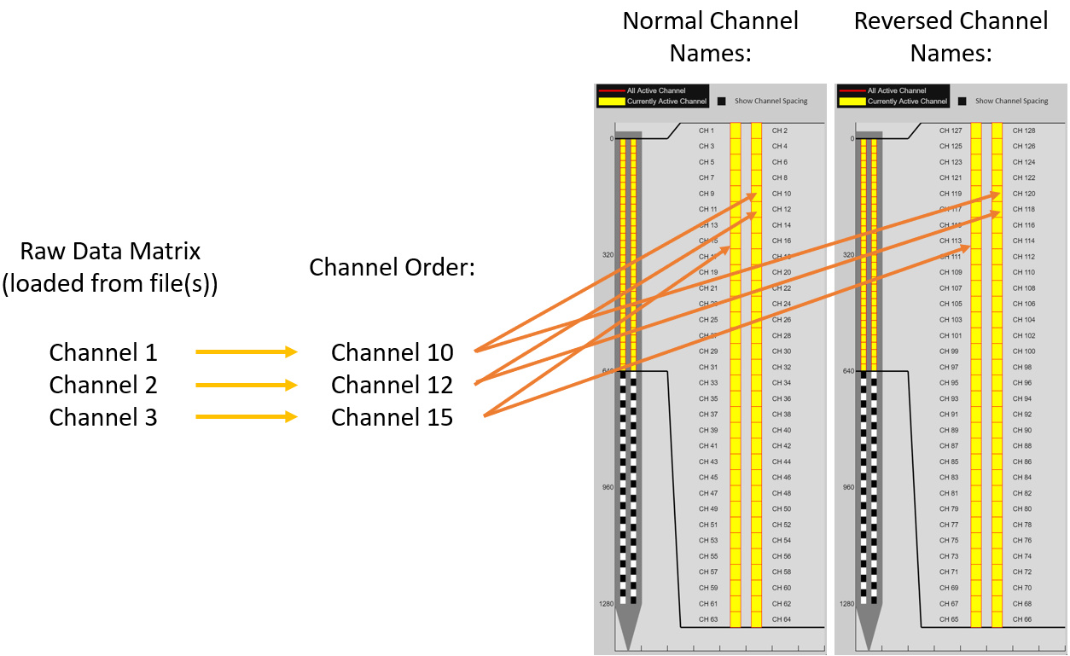
NOTE: If the channel names are reversed, channel 10 appears lower on the probe design (at position NrChannel - 10). Consequently, the first channel loaded from raw data would be assigned to row NrChannel - 10 in the data matrix and plotted as the NrChannel - 10 line in the analysis plots. However, this channel can still be activated or deactivated by clicking on the channel rectangle for channel 10 in the probe view window.
The ‘Active Channel’ field allows you to specify which channels are active on your probe for which data will be loaded. This means you can specify more channels for your probe design than you have available data channels. This feature is particularly useful for accounting for special recording parameters in Neuropixels probes and provides a better overview of the channel positions across the entire probe design, even if not all channels are used for data (see the second image of this section).
NOTE: If the Active Channel field is left empty, all channels are marked as active by default. You can always see which channels are marked as active in the probe view plot. The number of active channels must match the number of data channels loaded! If a channel order is specified, it must have as many elements as both the active and data channels.
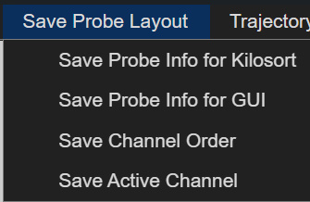
Channel orders and active channel configurations can be saved using the ‘Save Probe Layout’ option in the top left menu. Later, you can quickly load the saved configurations using the ‘Load Channel Order’ or ‘Load Active Channel Selection’ buttons.
Additionally, you can save your probe design as a .mat file using the ‘Save Probe Info for Kilosort’ option, which can be loaded into any external Kilosort GUI (Kilosort 3 and 4). When you finish setting up your probe, save all settings using the ‘Save Probe Info for GUI’ option. If you save the probe design in the folder ‘Path_to_GUI/Probe Layouts/Saved Probe Layouts’, it will automatically appear in the ‘Load Saved Probe Information’ menu in both this window and the ‘Extract Data’ window, allowing you to load it with one click (you may need to re-open the window to see the new probe design in the menu).
Once you’ve finished setting up your probe design, click the ‘Set Probe Information and Continue’ button at the bottom of the ‘Probe Layout’ window. This will close the window and display the probe information in the upper text area of the ‘Extract Data’ window. When you’ve also selected a data folder (visible in the same text area), you can proceed by pressing the ‘Extract Data’ button in the ‘Extract Data’ window.
During data extraction, a green bar will show the progress percentage, and additional information will be displayed in the upper text area, depending on the recording file type. Once data extraction is successful, this window will close, and you’ll see your data traces in the main window’s data plot, with full access to all other modules. Your dataset variable ‘app.Data’ will now contain the fields ‘Raw’, ‘Time’, and ‘Info’.

3.2 Save Dataset:

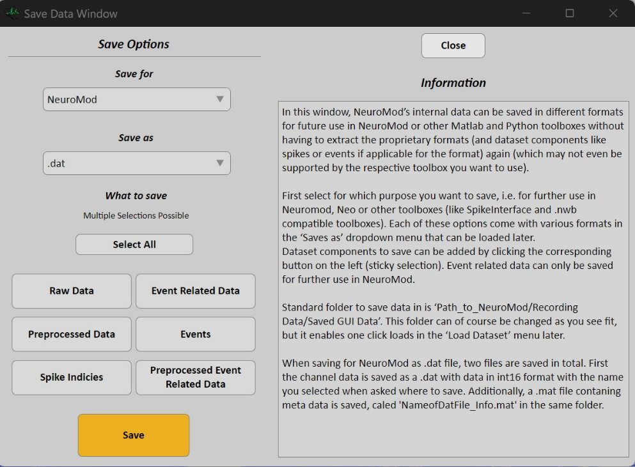
Selecting the ‘Save Dataset’ option in the ‘Manage Dataset’ module opens the ‘Save Data Window,’ where you can specify how and where to save your dataset.
First, you can choose the format in which to save the dataset. The available options are .mat and .dat. The recommended format is .dat because it is faster to save and load and requires less hard drive space.
Below the format selection, you can specify which dataset components to save by clicking the corresponding buttons. If a component is selected to be saved, the button will appear darker grey. The ‘Select All’ button will automatically mark all available components.
Once you’ve finished your selection, click the ‘Save’ button, which will prompt you to choose a folder and filename.
Explanation of data formats:
.mat format: When .mat is selected, all dataset components are saved in the variable ‘Data’ exactly as they are. This is ideal for preserving the original structure of all components, and it can be directly loaded into MATLAB without additional steps.
.dat format: When .dat is selected, the raw data (and preprocessed data, if selected) are converted into int32 and saved as binaries in the .dat file. If both raw and preprocessed data are saved, they are concatenated into a single nchannel x 2*ntime matrix. This format significantly improves saving and loading speed and reduces memory usage compared to .mat files. All other dataset components are saved in a separate .mat file that is always saved alongside the .dat file. Important: The .mat file must have the same name as the .dat file, with ‘_Info’ added at the end, ensuring a clear relationship between the .mat and .dat files when multiple datasets are saved in the same folder.

3.3 Load Dataset:

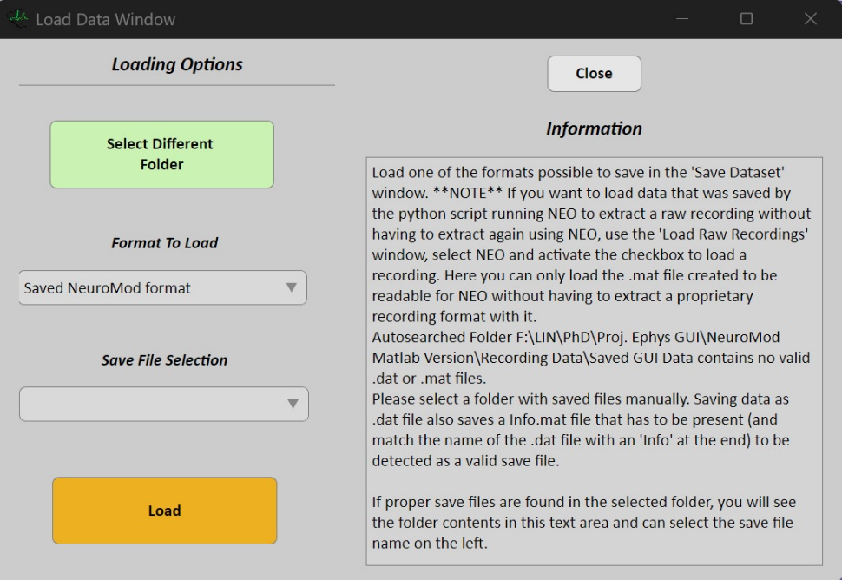
Selecting the ‘Load Dataset’ option in the ‘Manage Dataset’ module opens the ‘Load Data Window,’ where you can load datasets saved with the ‘Save Dataset’ option. Upon startup, the ‘Load Data Window’ will always search in the default directory ‘GUI_Path/Example Data,’ allowing for quick and easy file loading from this folder. If you wish to load a file outside of this folder, click the ‘Select Different Folder’ button. After selecting a folder, it will automatically search for the appropriate save files, which will then appear in the ‘Save File Selection’ dropdown menu (refer to the previous section about saving data for more details on the types of files that can be loaded).
There may be situations where both – .mat and .dat datasets are saved in the same folder. To handle this, the small dropdown menu below the ‘Select Different Folder’ button allows you to choose either the .mat or .dat file format for loading. Depending on your selection, only the files in the chosen format will appear in the ‘Save File Selection’ dropdown.
Once you've selected a dataset to load, click the ‘Load’ button to begin loading the dataset and display the progress.

4. Main Plot Analysis Module

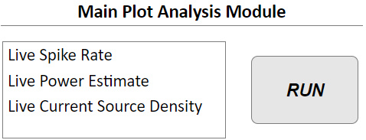
This module enables you to open three different types of analysis windows, each of which takes data from the main window data plot and displays the selected analysis results. The analysis plots in this module are synchronized with the main window data plot. This means that when you adjust the time points or range of the main window plot using the ‘Time Span and Axis Control’ panel or by clicking the time plot, both the main app data plot and the analysis plot of this module will update accordingly.

4.1 Spike Rate:

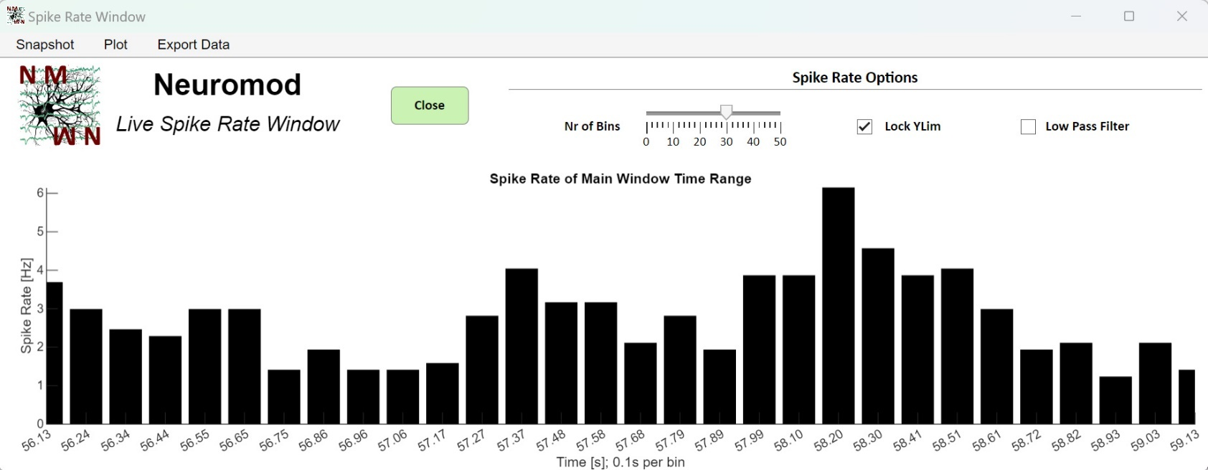
This window displays the spike rate of spikes within the main window plot's time range. The only requirement to open this window is a spike dataset. The spike rate is computed by binning spikes across all channels selected in the ‘Probe View’ window. Spike counts for each bin are divided by the channel number and time range of each bin to calculate the average spike rate over the selected depth. The number of bins can be adjusted using the ‘Bin Size’ slider, and the time range of each bin is shown in the x-label. Since this is a live plot, which means that it changes according to the main window plot time range and can display the results for many consecutive time points, you can lock the y limits of the plot to the biggest values seen so far with the ‘Lock YLim’ checkbox. This helps in comparing the spike rate for many consecutive time points.
Depending on the time range of the main window, the bin size may become very small (smaller than the spike durations themselves), causing spike rates to be artificially high. To mitigate this, the result can be low-pass filtered using the ‘Low Pass Filter’ checkbox. Right-clicking this checkbox allows you to adjust the cutoff frequency and filter order. By default, a Butterworth filter without phase shifting is applied.
The appearance of the plot can be modified using the ‘Plot’ menu at the top of the window. Additionally, you can export the x- and y-data displayed by using the ‘Export Data’ menu. The default save location for exported data is ‘GUI_Path/Analysis Results/Date_Time_AnalysisName.txt’.
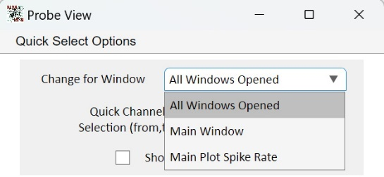
NOTE: The ‘Main Plot Spike Rate’ option in the ‘Probe View’ window allows you to control the effect of channel changes on the spike rate window without affecting the main window or other open windows.

4.2 Power Estimate:

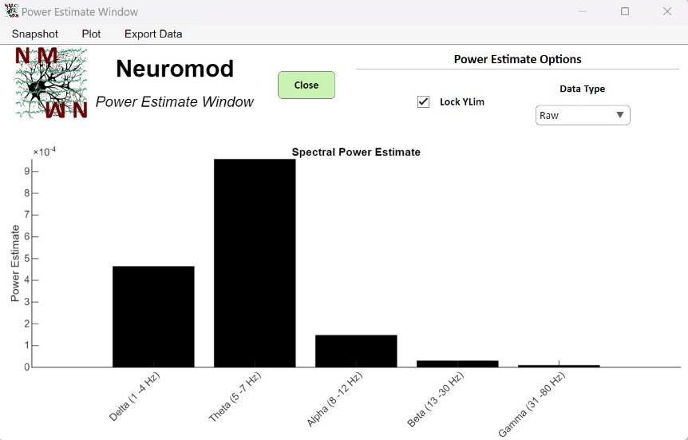
This window displays the power estimate of low-frequency components in the main window's data plot, categorized into alpha, beta, gamma, delta, and theta frequency ranges. The only prerequisite for this analysis is that your data has been low-pass filtered. Power is calculated across all channels selected in the Probe View window, either for the raw or preprocessed dataset, depending on what is selected in the ‘Data Type’ dropdown menu. Since this is a live plot, which means that it changes according to the main window plot time range and can display the results for many consecutive time points, you can lock the y limits of the plot to the biggest values seen so far with the ‘Lock YLim’ checkbox. This helps in comparing the power estimate for many consecutive time points. As with other windows in this module, the appearance of the plot can be customized using the ‘Plot’ menu at the top of the window. Additionally, you can export the x- and y-data displayed by using the ‘Export Data’ menu. The default save location for exported data is ‘GUI_Path/Analysis Results’.

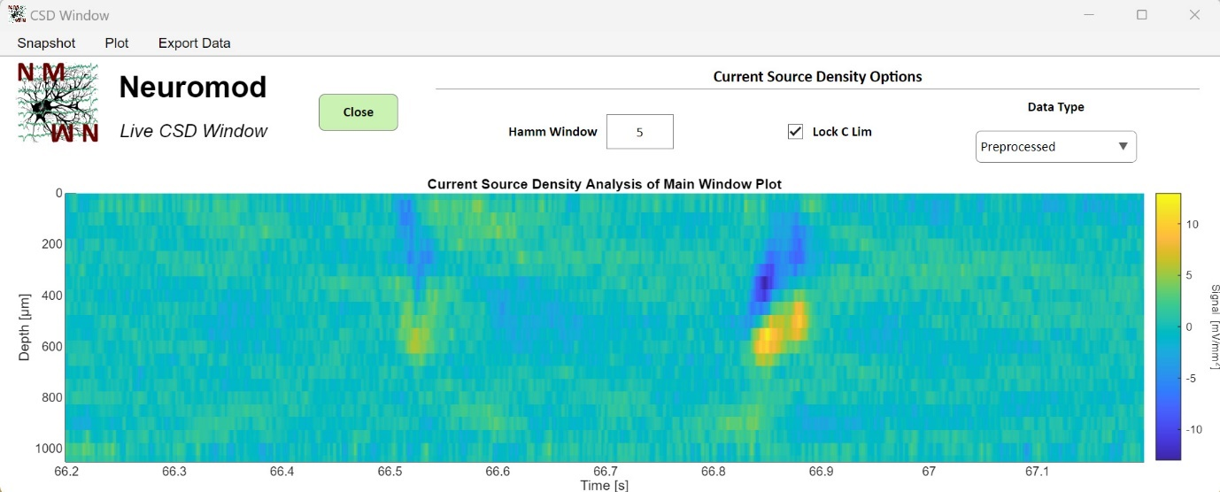
4.3 Current Source Density:

This window displays the current source density (CSD) of low-frequency components in the main window's data plot. The only prerequisite for this analysis is that your data has been low-pass filtered. CSD is calculated across all channels selected in the Probe View window, either for the raw or preprocessed dataset, depending on what is selected in the ‘Data Type’ dropdown menu. The results can be smoothed by adjusting the ‘Hamm Window’ edit field, though windows larger than 9 are not recommended. Since this is a live plot, which means that it changes according to the main window plot time range and can display the results for many consecutive time points, you can lock the y limits of the plot to the biggest values seen so far with the ‘Lock YLim’ checkbox. As with other windows in this module, the appearance of the plot can be customized using the ‘Plot’ menu at the top of the window. Additionally, you can export the x- and y-data displayed by using the ‘Export Data’ menu. The default save location for exported data is ‘GUI_Path/Analysis Results’.

5. Continuous Data Module

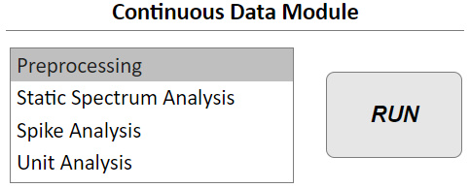
This module encompasses all the functionalities required to modify or analyze the entire data stream, i.e., your continuous dataset. Consequently, every analysis performed within this module shows results across all time points in your recording. It also serves as the central module for preprocessing your dataset. Since event-related data (described in the next module) is extracted either from the raw or preprocessed continuous dataset, this module is also the primary source for obtaining preprocessed event-related data. The ‘Preprocess Event Related Data’ window of the ‘Event Data’ module provides options to reject trials/events and channels, but it does not offer the same preprocessing options available in this module.

5.1 Preprocessing:

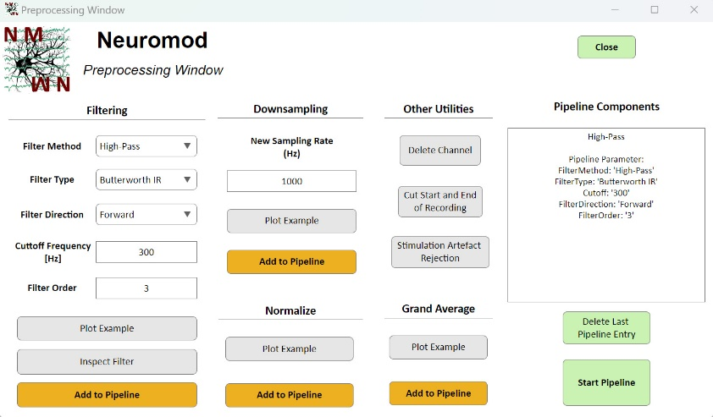
This window provides all the functionalities required to preprocess your dataset. Preprocessing creates the Data.Preprocessing field in the main dataset, which has the same size as the raw dataset. This has two important implications:
The raw dataset is always preserved, and all preprocessing steps can be reversed.
When you preprocess your data multiple times, the previously saved preprocessed data is overwritten. Therefore, this window allows you to assemble a preprocessing pipeline containing multiple steps, enabling you to apply several preprocessing methods without overwriting the dataset each time.
Preprocessing methods are organized into blocks, such as filter, downsampling, normalization, and grand average blocks, along with a block containing multiple utility functionalities for managing your dataset. All relevant parameters for each method can be selected within its respective block. The preprocessing method from the block can be added to the pipeline by clicking the ‘Add to Pipeline’ button. The text area on the right of this window shows all components of the current pipeline.
To evaluate how each method affects your data, you can use the ‘Plot Example’ button, which displays a small snippet of your dataset from one channel. For the filter block, you can also inspect the filter characteristics of the currently selected settings in both the temporal and spatial domains by clicking the ‘Inspect Filter’ button.
To remove previously added pipeline steps, you can use the ‘Delete Last Pipeline Entry’ button under the text area on the right side. If you wish to update the parameters of an already added pipeline step, you can add it again with the new settings. This will overwrite the previous settings.
Important: You cannot add both a high-pass and a low-pass filter to the same pipeline. The filter will simply be updated to the current setting when adding a new one. For example, if you first add a downsampling step and then a low-pass filter, the low-pass filter will be applied first to avoid aliasing.
The ‘Stimulation Artefact Rejection’ option is based on extracted event data representing stimulation time points. Without this event data being extracted from the ‘Event Data’ module (‘Extract Events and Data’ window), this step cannot be applied. Once applied, the artefact rejection becomes part of the preprocessed dataset. Event-related data extracted from the ‘Event Data’ module can also be pulled from the preprocessed dataset, ensuring the artefact rejection is visible in the event-related dataset.
The ‘Cut Start and End of Recording’ button opens a window in which you can specify how to trim your recording. You can either delete the beginning of the recording (from time 0 to the specified number of seconds) or trim the end of the recording (deleting the last seconds, as specified in the corresponding window: Time(end) - specified seconds).
NOTE: If you input a number of seconds in both fields, both the start and end of the recording will be deleted.
Once you are satisfied with the pipeline, click the ‘Start Pipeline’ button and wait until the progress bars disappear. The text area on the right side will display a message confirming that preprocessing was successfully applied.
After the pipeline has run and the Data.Preprocessing field has been added, you can view the preprocessed dataset in the main window plot using the first ‘Plot Selection’ dropdown menu, just like you would with the raw dataset.
NOTE: When you delete channels or time from your recording, these changes are also applied to the raw dataset to maintain internal consistency. This means these steps cannot be reversed, and you will need to extract the recording data again to undo them. These steps can also be applied multiple times.
NOTE: If you cut the time of your recording and wish to load spike sorting data, make sure that the dataset used for spike sorting was also time-trimmed. If there are any inconsistencies, a pop-up warning will notify you.

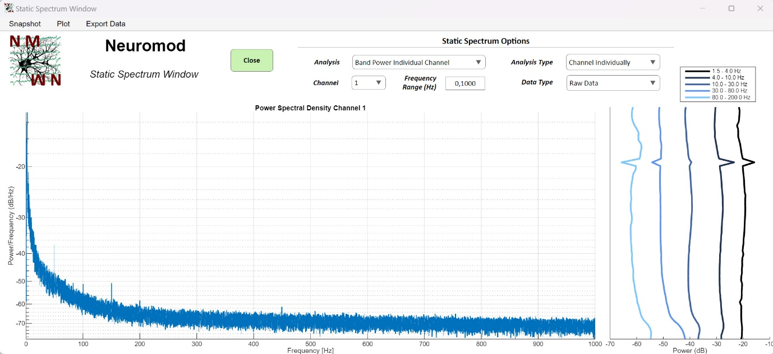
5.2. Band Power Analysis:

This window allows you to view the power analysis of individual frequency components in your dataset. When opening this window for the first time, the power across all channels is computed (indicated by the progress bar). This may take some time, depending on the length of your dataset and the number of channels, but it only needs to be done once, as the results are saved afterward. When you open the window again, the previously computed results are loaded.
Upon startup, you will see two plots and a control area at the top. The analysis shown in the left plot can be selected from the ‘Analysis’ dropdown menu. Available options include static spectrum analysis using the Welch method for individual channels or the mean across all channels. Additionally, you can plot the spectrum over the depth of all your probe channels. The plot on the right side displays the spectrum over all probe channels for low-frequency bands.
With the ‘Analysis Type’ dropdown, you can choose a power analysis plot for an individual channel or the mean across all channels when the analysis type is ‘Band Power Individual Channel’. The specific channel displayed can be selected in the ‘Channel’ dropdown. You can also modify the frequency range. If you have both preprocessed and raw datasets, you can select which dataset you want to display results for using the ‘Data Type’ dropdown.
As with other windows in this module, the appearance of the plot can be customized using the ‘Plot’ menu at the top of the window. Additionally, you can export the x- and y-data displayed by using the ‘Export Data’ menu. The default save location for exported data is ‘GUI_Path/Analysis Results’.

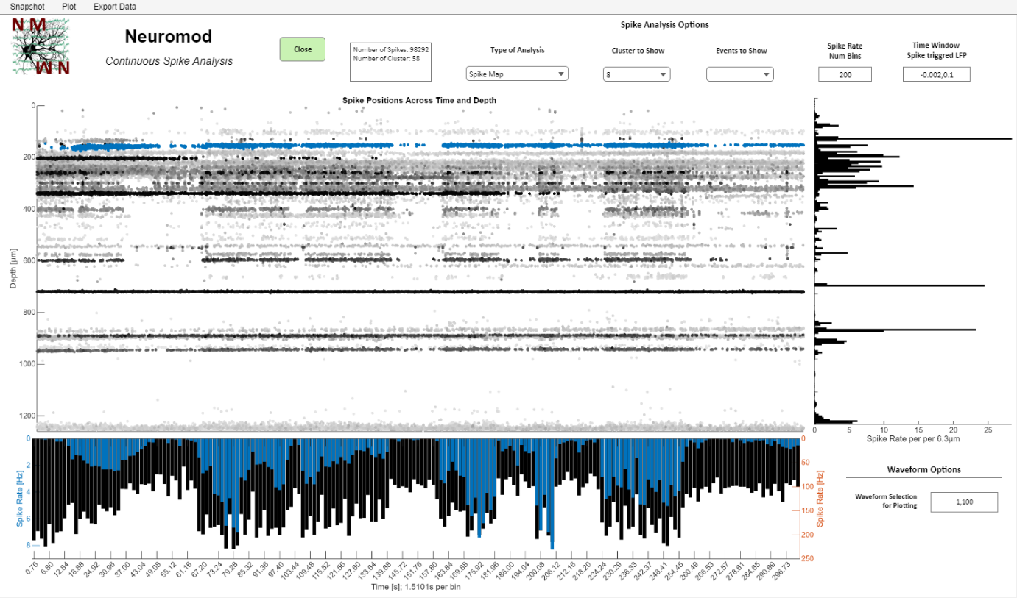
5.3. Continues Spike Analysis

This window is used for analyzing spike data across the entire recording (continuous spike analysis). It works with loaded Kilosort (3 and 4), Mountainsort 5, SpykingCircus 2, and WaveClus 3 spike data, as well as with internally extracted spike data that hasn't been sorted. Without spike sorting, individual spike clusters cannot be selected for display, and the analysis/visualization will include all spikes together.
The window consists of three plots and two panels to select plot/analysis options. The ‘Spike Analysis Options’ panel at the top contains all the relevant options you can modify to change the analysis shown in the plots, along with a small text area showing the number of spikes found and, if applicable, the number of spike clusters. The type of analysis displayed in the main plot in the center can be selected using the ‘Type of Analysis’ dropdown menu.
The ‘Spike Map’ option will plot all spikes found across the entire recording, color-coded by amplitude. The lighter the color, the lower the amplitude. The color and other plot appearances can be customized in the ‘Plot’ menu at the top of the window. As shown in the image above, you can highlight individual units by selecting them in the ‘Cluster to Show’ dropdown menu. Selecting ‘None’ will display all spikes without unit identification, while ‘All’ highlights each unit in a different color. The plotted depth for each plot where depth plays a role is controlled via the interactive channel selection in the Probe View window.
The ‘Spike Amplitude Density’ and ‘Cumulative Spike Amplitude Density’ options display the amplitude of spikes across depth, color-coded by spike rate. This can be used to evaluate whether individual clusters respond in a physiological manner. Generally, higher amplitudes should correspond to lower spike rates (this is also available for all spikes, not just units). The ‘Average Waveforms Across Channel’ option shows the average waveform across the entire probe depth. For each depth bin plotted, the number of waveforms specified in the ‘Waveform Options’ panel in the bottom-right corner are averaged and displayed. Since individual unit spikes can only be detected over a limited range of channels (or µm), you should see low/high amplitude peaks within a limited depth range. The ‘Waveforms’ option will display the largest spike waveforms found across all channels selected in the Probe View window. The number of waveforms shown can be adjusted in the ‘Waveform Options’ panel. The ‘Waveform Templates’ and ‘Template from Max Amplitude Channel’ options are only available for loaded Kilosort spike data and show the waveform templates used by Kilosort. Lastly, the ‘Spike Triggered LFP’ option will show the averaged LFP response over spikes for a specified time window. The time window can be adjusted in the ‘Time Window Spike Triggered LFP’ field in the ‘Spike Analysis Options’ panel. This requires low-pass filtered data to be present (and downsampled to reduce memory demands). If your main dataset does not yet contain low-pass filtered data, a window will pop up, informing you about this and allowing you to manually select the filter parameters. After clicking Proceed, your data will be low-pass filtered, and the spike-triggered average will be calculated. If you don't specify that the low-pass filtered data should become part of the dataset (as Data.Preprocessed), a low-pass filter will need to be applied again the next time you modify the spike-triggered average plot!
The plot below the main data plot shows the averaged spike rate across all channels, plotted for a specific time bin. The number of bins and the bin duration can be adjusted using the ‘Spike Rate Num Bins’ field in the top panel. When selecting a unit, this plot displays the average spike rate across all channels for that unit, highlighted in the same color used in the main plot when the ‘Spike Map’ analysis type is selected.
The plot to the right of the main data plot shows the average spike rate over the entire recording time and for a specific range of depth. When sorted spike data is available, the entire probe depth is divided by the number of bins selected in the top panel, allowing the spike rate to be averaged over a specified depth range for each time bin. For internally extracted spike data without sorting, this plot will always show one bar per channel, regardless of the bin settings in the top panel. In this case, each bar will represent the average spike rate over time for the specific channel spacing range (in µm).
As with other windows in this module, the appearance of the plot can be customized using the ‘Plot’ menu at the top of the window. Additionally, you can export the x- and y-data displayed by using the ‘Export Data’ menu. The default save location for exported data is ‘GUI_Path/Analysis Results’.

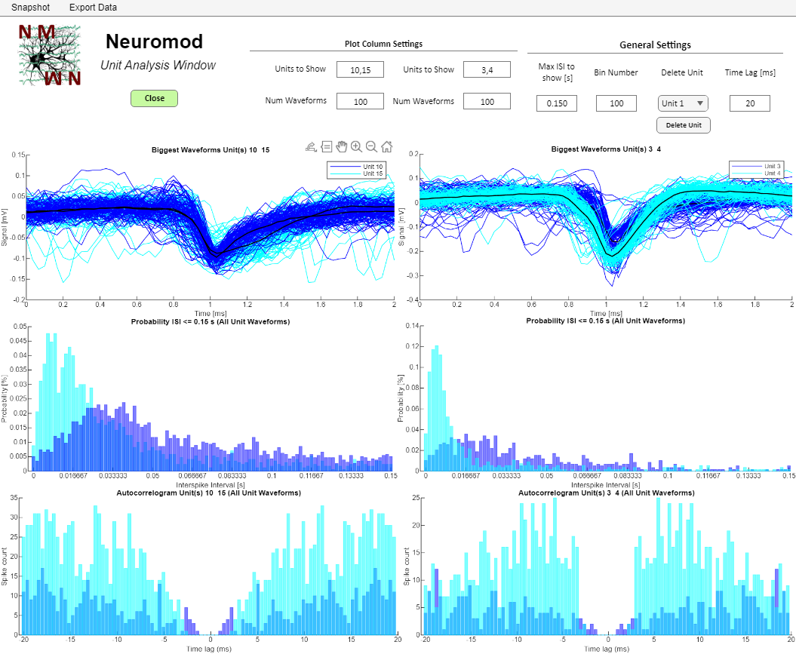
5.4. Continues Unit Analysis:

This window can be used to inspect various properties of your units. It requires spike sorting data to be loaded from one of the supported sorters. While it provides a general overview of sorting quality and allows you to delete units from the spike dataset, it is not a replacement for manual spike curation in Phy or the SpikeInterface GUI.
The window is essentially divided into two columns of plots, along with two sets of edit fields in the ‘Plot Column Settings’ panel. The ‘Units to Show’ and ‘Num Waveforms’ edit fields, located on the left side of this panel, control the left plot column. For example, the three plots on the left display properties of units 10 and 15 (as shown in the example image), while the plots in the right column display properties of units 3 and 4. From top to bottom, the window shows the waveforms (largest waveforms), the interspike-interval (ISI) distribution, and the autocorrelogram for the selected units. The number of waveforms plotted in the topmost plot is determined by the value specified in the ‘Num Waveforms’ edit field.
The ‘General Settings’ panel primarily contains analysis and plotting parameters. The ‘Max ISI to Show [s]’ field adjusts the range of ISIs plotted. The ‘Time Lag [ms]’ edit field specifies the time range for the autocorrelogram plot. The number of bins for the ISI and autocorrelogram plots can be modified using the ‘Bin Number’ edit field. Finally, you can delete a unit along with all corresponding spike information associated with that unit.
As with other windows in this module, you can export the x- and y-data displayed by using the ‘Export Data’ menu. The default save location for exported data is ‘GUI_Path/Analysis Results’.

6. Event Data Module
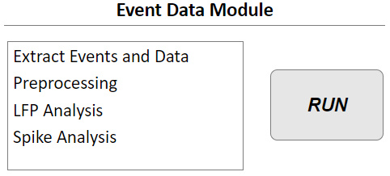
This module enables to extract events based on TTL signal recorded with your recording data as well as extract event related data. Analysis is divided into event related LFP and spike analysis, given you extracted or loaded spike data.

6.1. Extract Events and Data:

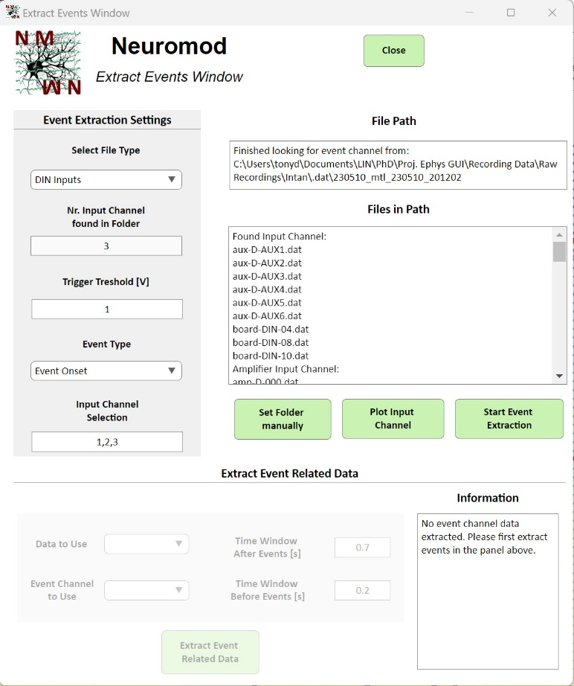
This window allows you to extract TTL events recorded by your recording system. The method of extraction depends on the recording system used. For example, with Intan systems, inputs from the analog, digital, and auxiliary input channels of the recording board can be recorded as continuous data streams with the same sample rate as the data channels. In contrast, Open Ephys systems record only signal changes in input channels as single timestamps representing event times. Consequently, the options and appearance of this window will vary slightly between different recording systems.
Event channel information is automatically searched for in the folder where the data was extracted (saved in app.Info.Data_Path). The text area will display information only if valid event channel data is detected. If the event channel data is stored in a folder outside your recording folder, use the ‘Set Folder Manually’ button to specify its location.
In the ‘Event Extraction Settings’ panel on the left, you can first select the type of event channel to extract events from using the ‘Select File Type’ dropdown menu. For Intan systems, you can select various input channel types. For Open Ephys recordings, you can select different recording nodes if available. The ‘Nr. Input Channel Found in Folder’ field is read-only and displays the number of detected event channels for the selected input event type. In the example shown on the right, the digital inputs contain three different event recordings.
For analog event signal captures, you need to specify a threshold for event detection in the ‘Trigger Threshold [V]’ field. This is necessary for recording types, such as those from Intan systems, which contain continuously recorded event data, to determine the time points of event onset or offset (when the signal crosses the threshold). For Open Ephys recordings, you can specify the event signal state (1 for event onset, 0 for event offset) to extract time points in this field. (NOTE: The field name may differ from what is shown in the example image.) For continuously recorded event data, you can also specify whether to extract the time points of event onset or offset using the ‘Event Type’ dropdown menu. When ‘Event Onset’ is selected, the first sample where the signal exceeds the threshold is extracted for each threshold crossing (the signal must fall below the threshold before a new event is detected). When ‘Event Offset’ is selected, the last sample is extracted.
The ‘Input Channel Selection’ field allows you to specify which event channels you want to extract data from. It is automatically populated with all detected channels. For instance, if three digital inputs are detected (and also selected as the File Type), but only channels 1 and 3 contain event data, you should modify the field from ‘1,2,3’ to ‘1,3’.
If you are unsure about which input channels are available, which ones contain the desired events, or which threshold to use, click the ‘Plot Input Channel’ button. This opens a window that automatically displays the signal of the first valid event channel with data. You can switch between other available event input channels to examine their signals. For recording systems without continuous recordings, the signal is artificially generated for plotting. In this case, the plot will show a state of 1 or 0 at each time point, depending on when the state changes.
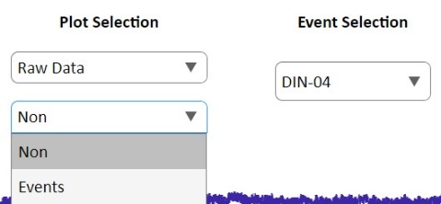
Once you have set the parameters, click the ‘Start Event Extraction’ button. If events are successfully extracted, the lower part of this window—the ‘Extract Event Related Data’ section—will be enabled. You will see information about the number of extracted events displayed in the text area on the top right. If no events are found, you will also be informed. This might occur if the threshold specified in the ‘Trigger Threshold’ field is never crossed by the event data. For Open Ephys and Neuralynx recordings, all detected events will immediately appear in a table in the text area field.
NOTE: Once events are extracted, an ‘Events’ option will be added to the ‘Plot Selection’ section of the main window. When enabled, the time points of each extracted event from the event channel selected in the ‘Event Selection’ will be displayed in the data and time plot of the main window. Additionally, the app.Data.Events field will be added to the dataset. This field is a cell array, with each cell containing the event samples for a specific event channel.
This functionality allows you to use the extracted event time points to retrieve recording data around these events for event-related analysis. The ‘Data to Use’ dropdown menu lets you select whether to extract event-related data from the raw or preprocessed dataset. It is recommended to use downsampled preprocessed data (along with other preprocessing methods you may apply), as this significantly improves performance. If events are extracted from multiple event channels, you can specify which channel to use with the ‘Event Channel to Use’ dropdown menu. Note that event-related data can only be extracted for one event channel at a time.
The ‘Time Window After Events [s]’ and ‘Time Window Before Events [s]’ fields allow you to define the time range to extract around each event. NOTE: The time before an event must be entered as a positive value, even though it represents negative time in event-related plots.
Once you’ve set the parameters, click the “Extract Event Related Data” button. After a successful extraction, an information message will appear in the text area on the lower right side of the window. This process adds the app.Data.EventRelatedData field to the dataset, which contains a matrix organized as channels × trials (events) × time. This also enables to open all event related analysis windows.
Important Notes:
If you extract events again, the previously extracted events will be overwritten. The same applies to event-related data.
If you extract event-related data based on a preprocessed dataset and then preprocess the data again, the event-related data will be re-extracted automatically from the new preprocessed dataset. However, make sure this behavior is as intended and that your event-related data is up-to-date.
If you delete event information from the dataset (app.Data.Events), the event-related data matrix will also be deleted automatically.
All relevant parameters for event extraction and event-related data extraction are saved in the app.Data.Info structure. These parameters are displayed in the ‘Recording Information’ text area in the lower-left corner of the main window.

6.2. Preprocessing Event Related Data:

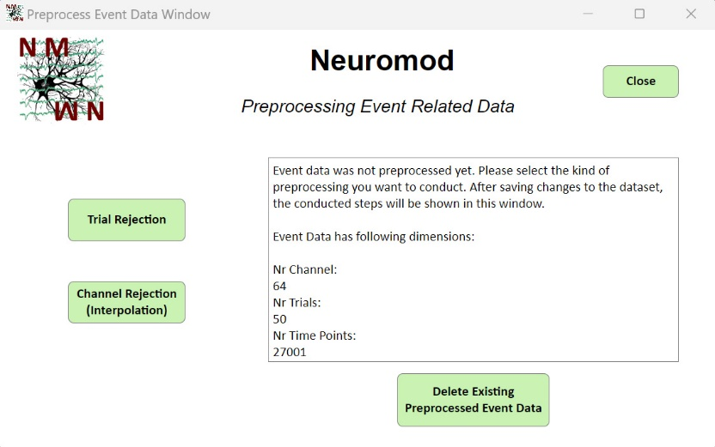
Although you can extract event-related data from your preprocessed continuous dataset, there are additional preprocessing steps specific to event-related data. Most importantly, this includes trial rejection and the interpolation of channel data if a channel is identified as broken (in addition to channel deletion, which is available for preprocessing the continuous dataset).
In this window, you will find information about your event-related dataset displayed in the text area on the right. It will also indicate whether the event-related data has already been preprocessed and provide details about the preprocessing steps that were performed.

6.2.1. Trial Rejection:

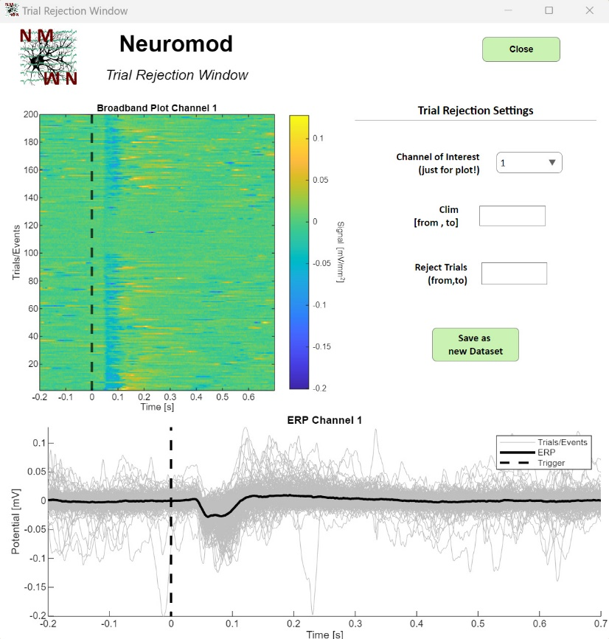
When you click the ‘Trial Rejection’ button, this window opens. The ‘Broadband’ plot displays the event-related signal for each event/trial. You can select which channel is shown by using the ‘Channel of Interest’ dropdown menu. As indicated in the window, this selection is only for plotting purposes! The color intensity of the plot can be adjusted using the ‘Clim’ edit field. For example, entering 1,2 will set the color scale to range from 1 to 2.
The lower plot shows the ERP (event-related potential) alongside the signal for each individual trial contributing to the ERP. This is plotted for the same channel selected in the broadband plot. If you identify noisy trials that should be excluded, list them in the ‘Reject Trials’ edit field. For example, entering 1,10 will mark trials 1 to 10 for exclusion, and this change will be reflected in the plots.
NOTE: These changes are only visualized at this stage and have not yet been saved as a new dataset! Once you are satisfied with your selection, click the ‘Save as New Dataset’ button to apply the changes. The updates will also be reflected in the ‘Preprocess Event Related Data’ window.

6.2.2. Trial Rejection and Interpolation:

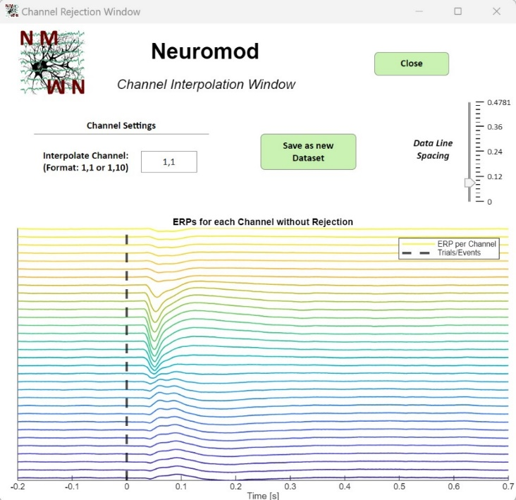
When you click the ‘Channel Rejection’ button, this window opens. You will see a plot of the ERP (event-related potential) for all channels (mean over events for each channel). If any channels appear noisy (e.g., due to a broken recording channel), you can specify them in the ‘Interpolate Channel’ edit field. For example, entering 10,10 will interpolate data for channel 10 based on data from channels 9 and 11. You can also specify multiple channels, such as 5,10, which will interpolate data for channels 5 to 10 linearly, using data from channel 4 and channel 11 as references.
Complete channel deletion can be performed in the preprocessing window for the continuous dataset. For better visualization, you can adjust the scale of the plot using the ‘Data Line Spacing’ selection.
Once you are satisfied with your selection, click the ‘Save as New Dataset’ button to apply the changes. These updates will also be reflected in the ‘Preprocess Event Related Data’ window.

6.3. LFP Analysis:
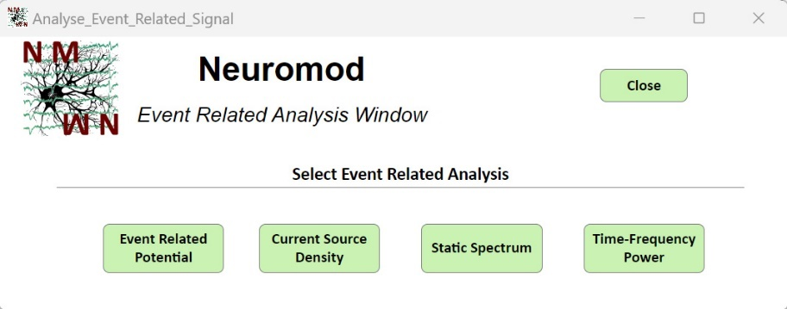
This window allows you to select and view analyses of your event-related data. Although it is called ‘LFP Analysis,’ you can also view event-related data extracted from raw data or high-pass filtered data—depending on what you selected during event-related data extraction.

6.3.1 Event Related Potential (ERP) Analysis:

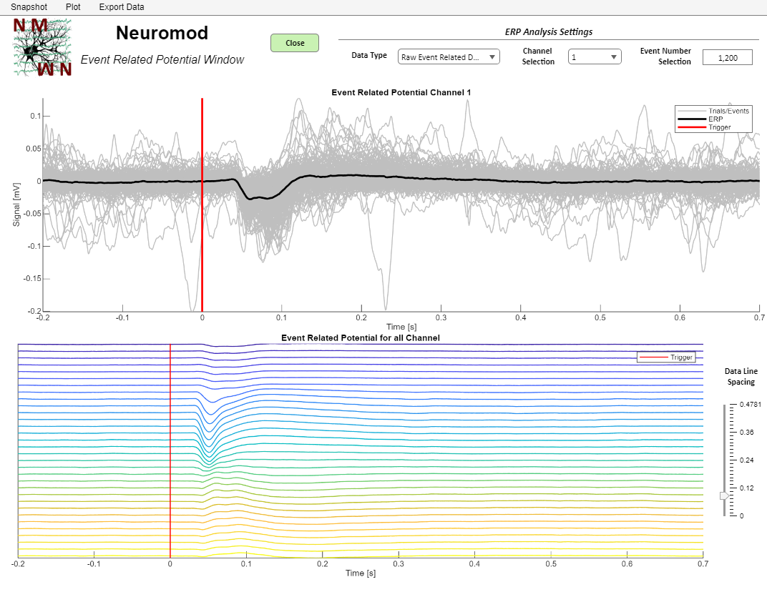
This window displays the ERP (event-related potential) for a single channel in the top plot, with individual trials contributing to the ERP shown in grey. Using the ‘Data Type’ dropdown menu, you can specify whether to view preprocessed event-related data, provided it was preprocessed in the ‘Preprocessing Event Related Data’ window. The ‘Channel Selection’ dropdown menu allows you to select the channel for which the ERP is displayed in the top plot.
The lower plot shows the ERP for each individual channel (as selected in the ‘Probe View’ window), arranged from top to bottom. The scaling between channels can be adjusted using the ‘Data Line Spacing’ menu located to the right of the plot.
For both plots, you can specify the number of events/trials to display using the ‘Event Number Selection’ edit field. field. An input of 1,10 will only show the first 10 events/trials.
As with other windows in this module, the appearance of the plot can be customized using the ‘Plot’ menu at the top of the window. Additionally, you can export the x- and y-data displayed by using the ‘Export Data’ menu. The default save location for exported data is ‘GUI_Path/Analysis Results’.

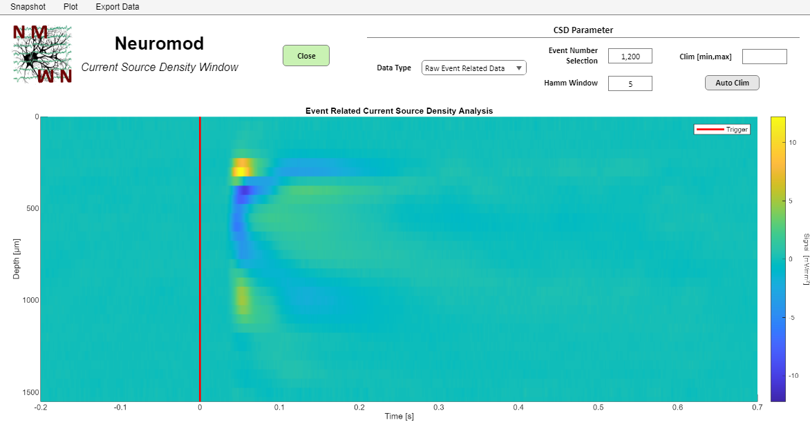
6.3.2 Current Source Density (CSD) Analysis:

This window displays the current source density analysis of your (preprocessed) event-related data across each channel specified in the ‘Probe View’ window. Using the ‘Data Type’ dropdown menu, you can select whether to view preprocessed event-related data, provided it was preprocessed in the ‘Preprocessing Event Related Data’ window.
You can specify the number of events/trials to display using the ‘Event Number Selection’ edit field. For example, entering 1,10 will show only the first 10 events/trials. The ‘Hamm Window’ edit field allows you to define the Hamming window, which is used to smooth the output.
The ‘Clim’ edit field lets you manually set the color limits; for instance, entering 1,2 sets the range from 1 to 2. To restore the original (automatically determined) color limits, you can use the ‘Auto Clim’ button.
As with other windows in this module, the appearance of the plot can be customized using the ‘Plot’ menu at the top of the window. Additionally, you can export the x- and y-data displayed by using the ‘Export Data’ menu. The default save location for exported data is ‘GUI_Path/Analysis Results’.

6.3.3 Static Spectrum Analysis:

See point 4.2. This window is identical to the one used for continuous static spectrum analysis, except that it operates on event-related data instead of the continuous dataset.
An ‘Event Selection’ edit field is provided, allowing you to specify the events/trials to visualize. For example, entering 1,10 will display the results only for events 1 to 10. Using the ‘Data Type’ dropdown menu, you can choose whether to display the spectrum for raw or preprocessed event-related data.

6.3.4 Time Frequency Power Analysis:

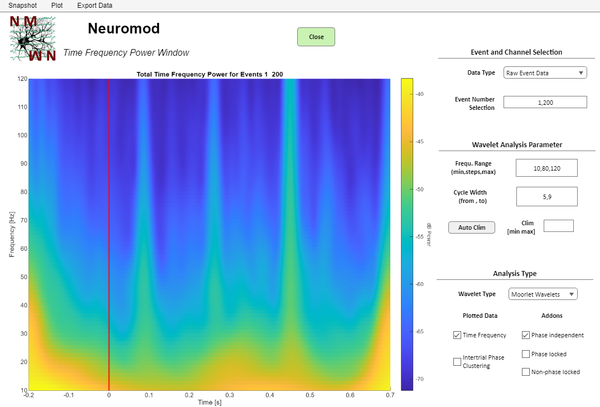
T This window displays the time-frequency power or intertrial phase clustering across all channels specified in the ‘Probe View’ window. The analysis is based on wavelet convolution with varying cycle widths to address the time-frequency tradeoff. This means that lower frequencies have better resolution in the frequency domain, while higher frequencies offer better temporal resolution.
Using the ‘Data Type’ dropdown menu, you can choose whether to display preprocessed or raw event-related data. The ‘Event Number Selection’ edit field allows you to specify which events/trials to analyze. For instance, entering 1,10 will display the results for events/trials 1 to 10.
In the ‘Wavelet Analysis Parameter’ panel, you can define the frequency range in the ‘Frequ. Range’ edit field. This field accepts three inputs. For example, entering 10,80,120 plots frequencies from 10 to 120 Hz with 80 steps between the lowest and highest frequencies. The ‘Cycle Widths’ edit field allows you to adjust the cycle widths, which determine the temporal and frequency resolution. Larger cycle widths improve frequency resolution.
The ‘Clim’ and ‘Auto Clim’ controls enable you to manually set the color range for the plot or reset it to the automatic default.
The ‘Analysis Type’ panel allows you to specify the type of analysis to plot. The checkboxes on the left represent the primary analysis options: time-frequency power plots (as shown in the example image) and intertrial phase clustering (ITPC), which analyzes the consistency of the timing of frequency-specific activity across trials.
The three checkboxes on the right further refine the selected analysis type. The analysis can be performed on the ERP or on all trials concatenated into a super trial.
- The ERP component for each channel preserves only phase-locked activity.
- Subtracting the ERP from the super trial, which contains both phase-locked and non-phase-locked components, isolates the non-phase-locked activity.
You can choose to display results for:
- Phase-independent activity (using super trials).
- Phase-locked activity (using only the ERP).
- Non-phase-locked activity (super trial minus ERP).
As with other windows in this module, the appearance of the plot can be customized using the ‘Plot’ menu at the top of the window. Additionally, you can export the x- and y-data displayed by using the ‘Export Data’ menu. The default save location for exported data is ‘GUI_Path/Analysis Results’.

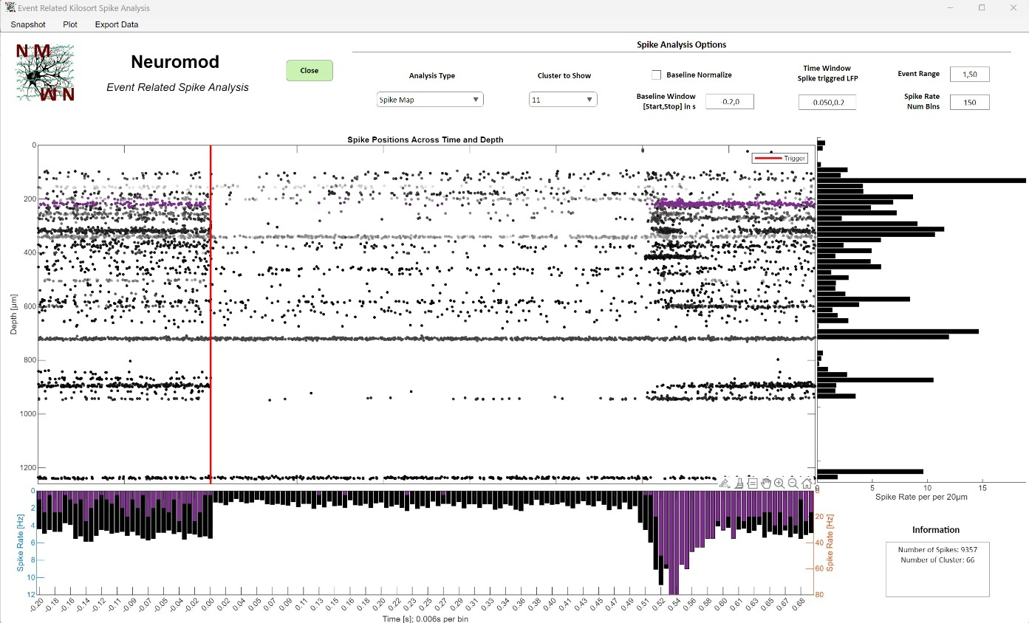
6.4. Event Related Spike Analysis:

See point 4.3. In its basic structure and function, this window is essentially the same as the spike analysis window for the continuous dataset. When you open this window, event-related spike activity is extracted from the dataset, saving all spikes that occurred within the time window around each event. This extraction happens every time the window is opened.
Displaying individual clusters only works when spike sorting results are loaded. If you are only extracting spikes using the internal thresholding methods, you can analyze and visualize all spikes together.
The only difference compared to the ‘Continuous Spike Analysis’ window is that, in this case, the only additional analysis types available in the ‘Analysis Type’ dropdown menu are ‘Spike Rate Heatmap’ and ‘Spike Triggered Average’.
The ‘Spike Rate Heatmap’ option shows a colormap of the spike rate over time, which can be baseline normalized using a time window specified in the ‘Baseline Window’ edit field. This normalization applies only when you enable the ‘Baseline Normalize’ checkbox.
As with other windows in this module, the appearance of the plot can be customized using the ‘Plot’ menu at the top of the window. Additionally, you can export the x- and y-data displayed by using the ‘Export Data’ menu. The default save location for exported data is ‘GUI_Path/Analysis Results’.

7. Spike Module

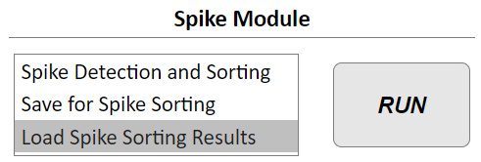
This modules can be used to perfrom a simple spike detection using varying thresholding mehtods. Moreover, data can be spike sorted using the python SpikeInterface library and with it Mountainsort 5, SpykingCircus 2 and Kilosort 4 all within this GUI. In order to perform the spike sorting, data can be saved in a format required for sorting. Lastly, spike sorting results from any of these sorters including the Kilosort 4 external GUI can be loaded.

7.1. Spike Detection and Sorting:

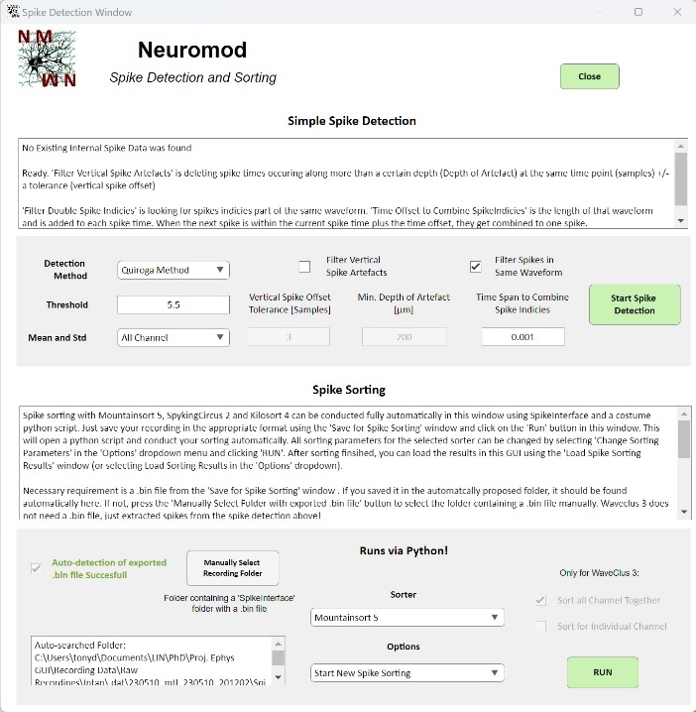
This window is fully focused on extracting spike data and conducting spike sorting using SpikeInterface. The upper part of the window, designated as ‘Simple Spike Detection,’ allows you to extract spike data from your high-pass filtered preprocessed dataset using simple thresholding techniques. Note that these spikes are NOT sorted. You can only analyze all spikes together in the respective analysis windows.
There are three methods available in the ‘Detection Method’ dropdown menu. Each method requires a manual threshold for detection. For example, the ‘Threshold: mean-std’ method detects spikes smaller than std * Threshold specified. This method will only detect negative spikes. The ‘Mean and Std’ dropdown menu allows you to choose whether the mean and standard deviation should be calculated for all channels (using a global mean and standard deviation for spike detection in each channel via the ‘All Channel’ option), or whether each channel should have its own mean and standard deviation.
Depending on the quality of your recording, vertical and horizontal spike filters are available. If you have recurring vertical artifacts, such as fast-changing signals across all channels in your recording, they may be detected as spikes, even after performing the grand average in preprocessing. Enabling the ‘Filter Vertical Spike Artifacts’ checkbox scans for spike times with the same time point +/- the number of samples specified in the ‘Vertical Offset Tolerance’. If spike times are the same +/- tolerance over a minimal distance specified in the ‘Min. Depth of Artifact’, they will be deleted. The number of channels this encompasses is determined by your channel spacing. For example, specifying 200 μm with a channel spacing of 20 μm means that the spike times must be the same +/- tolerance of samples over a minimum of 10 channels to be deleted.
Moreover, with every thresholding method, there is a possibility that multiple spike times could be detected within the same spike waveform. This depends on the specific combination of waveform shape and threshold. To avoid this issue, you can set a horizontal filter by enabling the ‘Filter Spikes in Same Waveform’ checkbox. This filter checks for spike times detected within the same waveform, within a time window specified in the ‘Time Span to Combine Spike Indices’ edit field. If multiple spike times are detected within this time window, only one spike time is saved at the point where the waveform is smallest (i.e., the time of the minimum of the waveform).
The ‘Start Spike Detection’ button initiates spike extraction. This creates the app.Data.Spikes structure and adds the spike detection parameters to the app.Data.Info structure. Afterward, these spike times can be used to create a new spike sorting using the Wave_Clus 3 toolbox (described below). Note that all other spike sorters will not take these spike times and will override them when they are loaded.
The lower part of the window, titled ‘Spike Sorting,’ allows you to conduct spike sorting using the Python package ‘SpikeInterface’ directly via MATLAB or via WaveClus 3 (which is MATLAB-exclusive). To use SpikeInterface, you need Python and Anaconda installed. Then, install all the necessary packages via the Anaconda Prompt using pip install. This includes not only SpikeInterface but also various sorters and other utilities required. You can find a list of necessary packages and further instructions in the README on GitHub or the GUI folder. Once the packages are installed, no additional Python setup is needed to use them for sorting data with Mountainsort 5, SpykingCircus 2, or Kilosort 4.
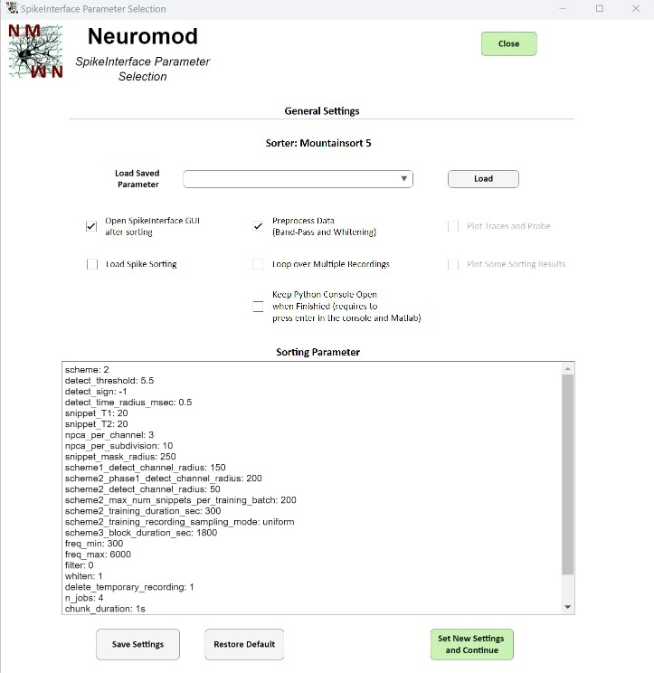
To begin sorting, you must first save your dataset as binary files within the GUI. This can be done in the ‘Save for Spike Sorting’ window (described below). The ‘Spike Detection and Sorting’ window automatically looks for the required binary file in a standard folder. When you save your dataset for sorting and do not specify a custom folder, it is automatically saved in the standard folder located at Recording_Path/SpikeInterface. If the binary file is found in this folder, a green message will appear stating ‘Auto-detection of exported.bin file Successful’. Otherwise, a red message will indicate that the .bin file was not found. WaveClus_3 does not require a .bin file, only the detected spike times in the upper part of this window. If you save the .bin file outside the standard folder, you can manually select the folder containing the file using the ‘Manually Select Recording Folder’ button.
The spike sorter you wish to use can be selected from the ‘Sorter’ dropdown menu. For each selected sorter, different options will be available in the ‘Options’ dropdown menu. The selected option will be executed when you press the ‘RUN’ button on the right. ‘Start New Spike Sorting’ initiates the sorting and opens the Anaconda command prompt.
NOTE: MATLAB will become unresponsive while the Python script is running. It will only become responsive again once the Python console is closed, and you press Enter in the MATLAB console, provided you’ve enabled the ‘Keep Python Console Open after Finished’ checkbox in the ‘Spike Sorting Parameter’ window (checkbox described below in more detail).
The first time you run this, you will be asked to select the python.exe file from the Anaconda environment where you installed SpikeInterface and the other required packages. If you did not install these in a specific environment, the default path is C:\ProgramData\anaconda3\python.exe. After this, a Python console will open showing the status of the spike sorting process.
NOTE: When you select pythonw.exe, the console won't open! The sorting will still proceed and will notify you once it's finished, but no progress feedback will be provided.
When you set the ‘Option’ dropdown menu to ‘Change Sorting Parameter’ and click the RUN button, a new window will open, providing general options for the Python spike sorting via checkboxes at the top.The ‘Open SpikeInterface GUI after sorting’ option will automatically open the SpikeInterface GUI once the sorting is complete. This allows you to immediately view and curate the spike sorting results.
NOTE: If this option is enabled, the SpikeInterface GUI must be closed before MATLAB becomes responsive again!
The ‘Preprocess Data’ checkbox will enable preprocessing of the data saved in the .bin file using SpikeInterface in Python. This means you only need to save your raw dataset as a .bin file for sorting.
The ‘Plot Traces and Probe’ checkbox will plot the raw and preprocessed data traces used for sorting within a fixed time window for sanity checking. It will also plot the probe design used by SpikeInterface. This design is automatically created based on the probe layout specified when extracting the recording and serves as a sanity check.
NOTE: When this option is enabled, the plots must be closed before the Python script can continue running. You cannot enable this and then open the SpikeInterface GUI afterward. Only one of these options can be enabled at a time.
The ‘Load Spike Sorting’ checkbox will load the results from a previous sorting session performed with the same sorter. In this case, the data won't be sorted again. Saved sorting results are located in the standard folder: Recording_Path/SpikeInterface/SpikeInterface_Saved_Sorting/Sorter_Name.
The ‘Loop over Multiple Recordings’ checkbox enables automatic sorting of multiple recordings. These recordings must be in the same folder with a subfolder for each recording. To use this feature, save each dataset beforehand as a .bin file in the standard folder (Recording_Path/SpikeInterface). The script will then loop over each recording folder, load the .bin file, conduct sorting, and save the results for each recording.
NOTE: If you’ve selected to open the SpikeInterface GUI or plot results/probes/traces, those must be closed for the Python script to continue. When this option is enabled, you need to select the folder containing all recordings using the ‘Manually Select Recording Folder’ button. The text in the ‘Spike Detection and Sorting’ window will change to red, prompting you to select a folder with multiple recordings. Then, change the ‘Option’ dropdown to ‘Start New Spike Sorting’ and click the RUN button to start sorting across multiple recordings. Alternatively, use the Autorun function in the GUI.
The ‘Plot Some Sorting Results’ checkbox will plot summary results for the first three clusters found.
NOTE: These plots must be closed for the Python script to continue.
The ‘Keep Python Open when Finished’ checkbox will prevent the Python console from closing automatically when the sorting is complete. This option is useful for debugging or checking for errors. However, you need to press ENTER twice in the Python console to close it, and also press ENTER in the MATLAB command window. Otherwise, MATLAB will remain unresponsive.
Each sorter has its own specific settings to fine-tune the sorting results for your dataset. These settings are displayed in the ‘Sorting Parameter’ text area in the ‘Spike Detection and Sorting’ window. You can modify each of these values, but ensure you enter them in the correct format (either a number or string) and avoid changing the variable names. These custom settings will be applied to the sorter in the Python script. You can always verify the settings used in the Anaconda/Python console during the sorting process.
To save these custom settings for later use, click the ‘Save Settings’ button. The settings will be saved in the folder Recording_Path/Modules/SpikeInterface/Saved_Spike_Sorting_Parameter. After saving, the settings will appear in the ‘Loaded Saved Parameter’ dropdown at the top of the window. You can click the ‘Load’ button to apply these saved settings automatically. To restore the default settings for the selected sorter, click the ‘Restore Default’ button.

7.2. Save for Spike Sorting:

This window allows you to save your recording data in a format compatible with Kilosort 4 or SpikeInterface (which also supports Mountainsort 5, SpykingCircus 2, and Kilosort 4). This step is required for conducting spike sorting in the ‘Spike Detection and Sorting’ window. The reason this is a separate window is that you may also wish to conduct spike sorting manually using your own Python script or the user interface of the respective sorter you plan to use. This separate window ensures you only save the data once, which helps save time and resources.
The window displays some information at the top, including the auto-selected save path. The specific path depends on what you select in the ‘Spike Sorter’ dropdown menu. When you choose to save your data for external Kilosort GUI usage, the output folder will be Recording_Path/Kilosort. If you select SpikeInterface, the standard save folder is Recording_Path/SpikeInterface. It’s highly recommended to retain the standard folder structure for seamless and automatic loading in the GUI and for using the Autorun function (see the respective section).
Depending on the sorter you choose, you can select a format using the ‘Format’ dropdown menu. For Kilosort, you can save in either int16 or int32 format. While there is no significant difference, you will still need to select the data type in the Kilosort GUI. The data is first converted into integers and saved in binary format, along with the scaling factor, so that Kilosort can scale it back to mV later.
When you click the ‘Save’ button, a folder named Kilosort will be created in your recording folder (if it doesn’t already exist). This folder will contain a .dat file for loading into Kilosort, along with a .mat file that stores the scaling factor.
NOTE: When analyzing this data in the external Kilosort GUI, save the results in the standard folder Path_of_dat_file/kilosort4 for easier later use! The last necessary item for the external Kilosort GUI is the probe design, which can be saved when creating the probe layout in the Probe Layout window (see point 2.3.1).
Additionally, the ‘Dataset’ dropdown menu allows you to select whether you want to save the raw or preprocessed dataset for spike sorting. For use in the external Kilosort GUI, it’s recommended to save the raw dataset. If you’re saving for SpikeInterface, it depends on whether you want SpikeInterface to handle preprocessing. If you do, save the raw data; if not, save the preprocessed data (at least high-pass or band-pass filtered) from this GUI and specify in the ‘Sorting Parameter’ window of the ‘Spike Detection and Sorting’ window that you do not want SpikeInterface to perform preprocessing. By default, SpikeInterface will preprocess the data, so you should select raw data here.
When saving for SpikeInterface, a .bin file will be saved in the standard folder in double precision format. NOTE: Preservation of scaling factors is not yet implemented, so no scaling factor file will be saved.
NOTE: Standard filenames will always correspond to the name of the recording folder from which the dataset was originally extracted (this can be seen in the ‘Recording Information’ text area of the main window).
NOTE: You can also use Kilosort 4 via SpikeInterface. However, SpikeInterface will look for the saved .bin file in the Recording_Path/SpikeInterface folder. The Recording_Path/Kilosort folder is only for use with the external Kilosort GUI.

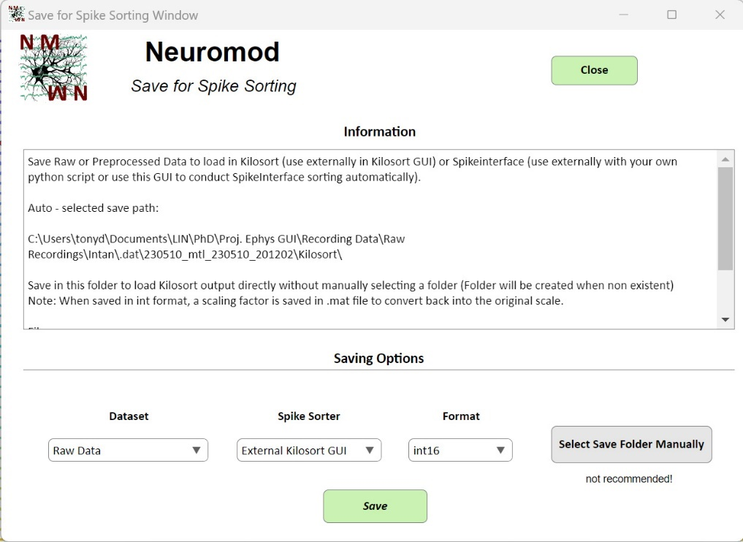

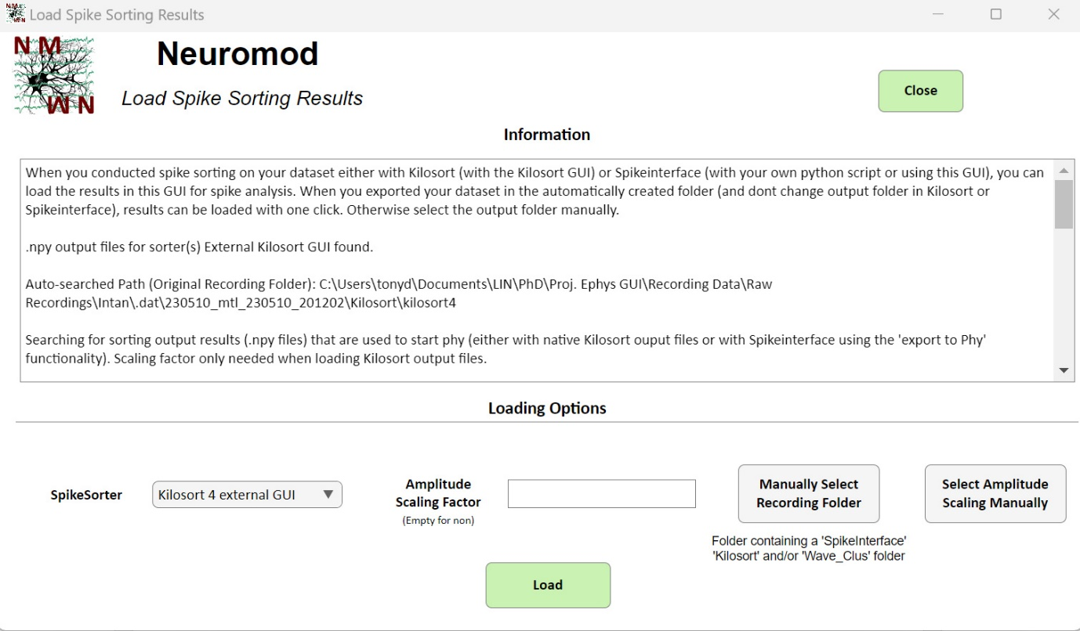
7.3. Load Spike Sorting Results:

After completing spike sorting either manually or using this GUI, you can load the sorting results and spike data using this window. Upon startup, the window automatically searches all standard folders where sorting results are saved. When using the external Kilosort GUI, save the .dat file for the sorting in the standard folder (Recording_Path/Kilosort) and let Kilosort save the sorting results in the standard folder (Path_of_dat_file/kilosort4). The Kilosort results will be auto-detected here and can be loaded with a single click on ‘Load’ (the ‘Information’ text area should display information similar to the above).
If you conducted spike sorting using SpikeInterface with this GUI, save the .bin file necessary for sorting in the standard folder (Recording_Path/SpikeInterface), and the results will automatically be saved in the standard folder searched by this window (Recording_Path/SpikeInterface/SpikeInterface_Sorting_Phy_Results/Mountainsort 5, SpykingCircus 2, or Kilosort 4). The Python script executed by this GUI saves the results as .npy files in the standard folder, allowing for one-click loading in this window. For sorting with WaveClus_3, results are expected in the standard folder Recording_Path/Wave_Clus.
NOTE: The window automatically searches for ‘.npy’ output files in the standard folder!
To select the sorter from which you want to load results, use the ‘SpikeSorter’ dropdown menu. When changing the sorter, the ‘Information’ text area will automatically update and show whether results for the selected sorter were found, along with the folder where they were searched.
If the sorting results are stored in a folder different from the standard ones above, either because you saved the necessary .dat and .bin files in a manually selected folder or used your own sorting pipeline, you can manually select the folder containing the output files using the ‘Manually Select Recording Folder’ button. To maintain internal consistency and avoid conflicts with other folder names, the standard folder names shown above must be present in the folder you manually select. For example, it should contain the folder Manual_Path/Kilosort/kilosort4, Manual_Path/SpikeInterface/SpikeInterface_Sorting_Phy_Results/Sorter_Name, or Manual_Path/Wave_Clus.

If you performed sorting with your own SpikeInterface pipeline and wish to load the results, you must export the SpikeInterface sorting analyzer as .npy files using the export_for_phy function. Additionally, you need to save a .mat file containing the spike depths (named SpikePositions.mat), which comes from the spike_locations property of the sorting analyzer object. For more information, refer to the README file. If you used the external Kilosort GUI for sorting, there is no need to save extra files as Kilosort handles this automatically.
When saving a recording for Kilosort sorting using the external GUI (in the ‘Save for Spike Sorting’ window), a .mat file containing the scaling factor for conversion back to mV is saved alongside the .dat data file. This file can be used when loading the Kilosort sorting results in this GUI. When selecting a folder containing the Kilosort results (or when the standard folder is checked), the window automatically searches for the amplitude scaling file. If found, the ‘Amplitude Scaling Factor’ edit field will display the corresponding factor, and the ‘Information’ text area will confirm the file's presence. Alternatively, you can manually select a .mat file holding the scaling factor using the ‘Select Amplitude Scaling Manually’ button or input the factor manually in the corresponding edit field (the .mat file must contain a variable named scalingFactor).
NOTE: This scaling factor functionality only works with Kilosort sorting results from the external Kilosort GUI (NOT with Kilosort via SpikeInterface).
Click on the ‘Load’ button to start loading the sorting data.
NOTE: When spike data is extracted, waveforms are extracted based on the spike time points and saved as in the app.Data.Spikes.Waveforms structure. For proper scale, data has to be high-pass filtered. If you should not have a high-pass filtered preprocessed dataset present at the time of loading sorting results, a window will open automatically to perform high pass filtering. You can specify the filter properties and select, whether you want to replace your current preprocessed dataset with the high-pass filtered one.

8. Autorun Function

When you have multiple recordings with the same probe design and wish to analyze them using the same pipeline, the Autorun function of this GUI can be utilized. This applies to simple tasks, such as saving the raw recording in a format compatible with spike sorting, as well as for a complete LFP and Spike analysis. All functions and analysis plots available in the GUI can be automatically applied, with the results saved as images in the recording folder (Recording_Path/Matlab).
NOTE: It is highly recommended to familiarize yourself with the GUI first, as all functions and parameters are tied to specific parts of the GUI. Understanding how each parameter works will make it easier to set up the analysis configuration file correctly.
To use the Autorun feature, simply open the Neuromod GUI and go to the ‘Autorun Manager’ window by selecting the corresponding menu option at the top of the main window. There is no need to load a recording beforehand. From the Autorun Manager, you can configure everything necessary for the process and fully customize your analysis pipeline.

8.1 Config File:

The central element of the setup is the Config file, a Matlab file (.m) that can be configured to execute all functions of various modules with custom settings. It consists of a structure named AutorunConfig. Each field in this structure corresponds to a specific aspect of the GUI functionality and contains several subfields, each defining parameters for the analysis.
For example, the AutorunConfig.PreprocessCont field contains multiple subfields to specify parameters for preprocessing your continuous data stream (such as FilterMethod, which determines whether a high-pass, low-pass, or bandpass filter should be applied). The parameters you can specify are the same as those available in the GUI and generally have the same names as in the interface. The modules and functions represented by each field are commented above their respective parameters.
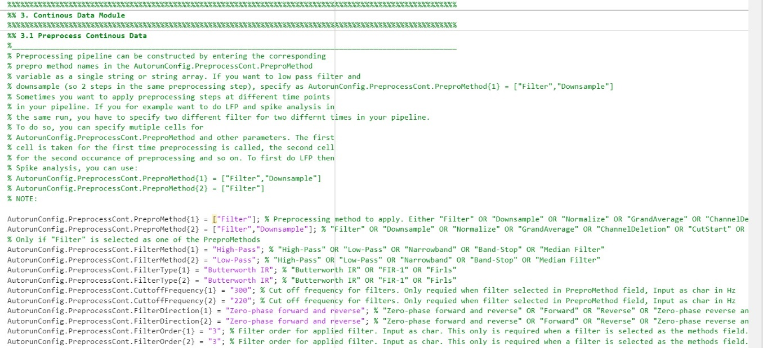
The AutorunConfig.PreprocessCont field can be found under the following comment:

Config files are saved in the folder GUI_Path/Autorun Configs/Config_Files. There is one example config file for each file format supported by the GUI. Since the config files in this folder are intended to be modified, which could potentially corrupt variable names or parameter formats, there is a template for every config file with standard settings located in the folder GUI_Path/Modules/MISC/Default Autorun Configs (do not edit!). This ensures that you can always restore the modified config files to their default settings if something goes wrong. You won’t need to worry about specific save paths, as everything can be managed through the ‘Autorun Manager’ window (see below for more information).
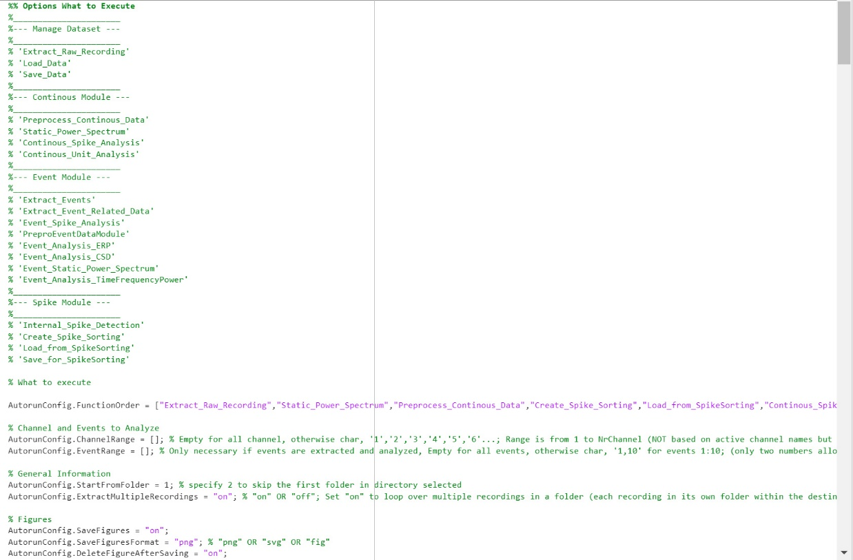
To assemble your analysis pipeline, you must first define the sequence of tasks to be performed before altering individual parameters. This can be done at the top of the config file. It displays the available options, which include each function of each module. You can enter the function name you see there in the Autorun.FunctionOrder variable in any order you prefer. The example config files illustrate the steps required for LFP and spike analysis. For instance, it first loads a raw recording, computes the static power spectrum, saves the result as an image, then preprocesses the data (high-pass filter), loads spike sorting results, saves spike analysis figures, and so on. For each step, you will find the corresponding parameters listed below.
The first element of this vector must always be either Extract Raw Recording or Load_Data! Since functions not listed in the FunctionOrder variable will not be executed, there’s no need to comment out parameters related to those functions. Simply modify the parameters related to your pipeline.
As you won’t have access to the ‘Probe View’ window during the Autorun analysis, you must specify which data channel should be plotted in the config file. This can be done using the AutorunConfig.ChannelRange variable. Similarly, use the AutorunConfig.EventRange variable to specify the number of events to plot. The other settings in the config file before the parameter selection (e.g., AutorunConfig.StartFromFolder, AutorunConfig.SaveFigures) are the same as those in the Autorun Manager window and should be specified there.

8.2. Autorun Manager Window:
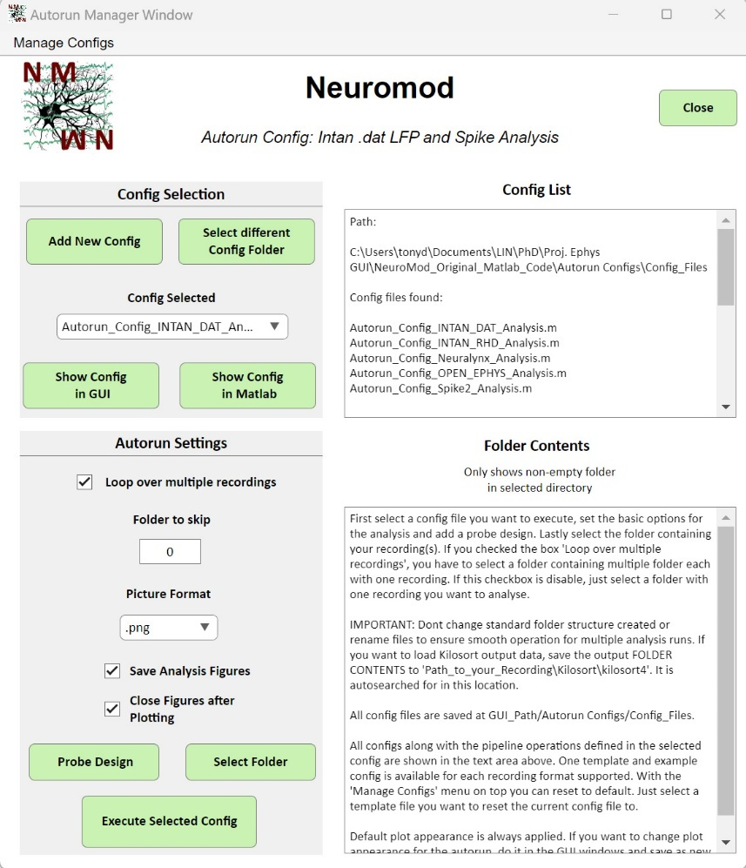
The ‘Autorun Manager’ window is the central point for managing all aspects of the Autorun analysis. The top part of this window is dedicated to selecting the Autorun Config file you wish to execute. There is an example config for every recording format supported by the GUI. In the ‘Config List’ text area, you can see the path searched for config files, along with the files found and additional information. All available files can be selected from the ‘Select Config’ dropdown menu. By clicking the ‘Show Config in GUI’ or ‘Show Config in Matlab’ button, you can open the selected config to modify parameters or the pipeline function order. A new config file can be created by clicking the ‘Add New Config’ button, which opens a window where you can choose a template on which to base your new config. This gives you a starting point with all the essential variables.
If you have config files that are not saved in the standard folder Recording_Path/Autorun Configs/Config_Files, you can manually select a folder by clicking the ‘Select different Config Folder’ button and choosing the folder containing your config files.
The lower part of this window, within the ‘Autorun Settings’ panel, is for additional settings, such as selecting the folder with all your recordings and specifying the probe design. If the ’Loop over multiple recordings’ checkbox is enabled, the system will loop over multiple recording folders within a selected folder. When it is disabled, only a single recording folder is analyzed. This choice determines which folder you need to select. If the checkbox is active, select a folder that contains multiple recording folders; if it is disabled, just select a single recording folder. The ‘Folder to skip’ option is only effective when the checkbox to loop over multiple recordings is active. The number entered in the edit field specifies how many recording folders in the selected folder should be skipped. This is useful if an error occurred with a particular recording, allowing you to resume the analysis loop without repeating the analysis for already processed recordings.
The ‘Picture Format’ dropdown menu specifies the format in which the selected analysis visualizations will be saved (saved in Recording_Path/Matlab).
When you click the ‘Select Folder’ button and choose a folder, it will be displayed in the ‘Folder Contents’ text area on the right. The same happens when you specify a probe design by clicking on the ‘Probe Design’ window.
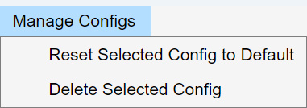
The ‘Manage Config’ menu at the top of the Autorun Manager window offers additional options to manage your Autorun config files. The first option, ‘Reset Selected Config to Default,’ can be used if your currently selected config file is no longer working and you want to restore it to the default template saved in Recording_Path/Modules/MISC/Default Autorun Configs (do not edit!). The second option, ‘Delete Selected Config,’ deletes the currently selected config file.

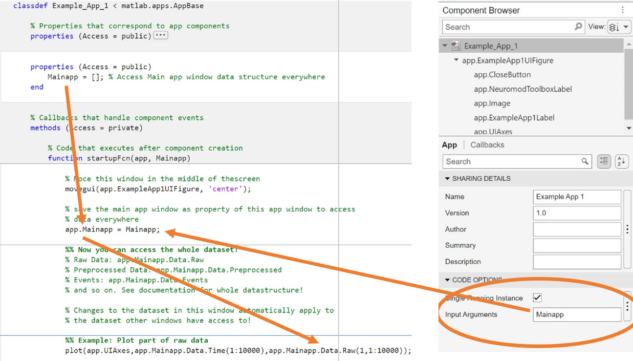
9. Creating and adding your own Module

This toolbox gets its name from its modular design. Each module is essentially a category that contains several functions, which together form the module. Each function has one main app window (and additional support windows, if needed) as well as MATLAB functions to execute the windows. Every time a window is opened, the main window app object—containing the app.Data structure with all GUI data—is passed to that window. This setup provides real-time access to the entire dataset, and any changes made to the app.Data structure are automatically reflected in every other window that is open. This, combined with the main window design, allows you to easily add your own module and functions to the overall GUI ecosystem with just a few steps.

If you want to create your own module and integrate it into the toolbox, you can get started with the example module saved in the folder Recording_Path/Modules/Example Module - This Could Be Yours!. This folder contains a main app window with the basic code (just a few lines) and explanations on how to access the entire dataset and plot a simple figure. Open the example in MATLAB App Designer to see how it works. The most important part of calling the window to open is to pass the app object of the main window as an input argument. In the example below, the app object is passed as the variable Mainapp to the new window. It is then saved in a public property of the new app window, also called Mainapp. This means the variable app.Mainapp holds the main window app object, which can be used to access the Data variable through app.Mainapp.Data and modify it as needed. In the example, the window simply plots a portion of the raw data in an app.UIAxes object (which behaves like a figure, but is attached to the new window and referred to as UIAxes).

NOTE: The Mainapp variable in the new window must be a public property so that all GUI callback functions can access it!

To run the new window you created, you need a ‘RUN’ function. For the example module, the function is called RUN_Example.m and is saved in the same folder as the example window. This function checks which option the user selects in the main app (e.g., ‘Preprocessing’ for the Continuous Data Module) and calls the respective window with the main window app object as the input argument. For example, if the user selects the ‘Preprocessing’ option of the Continuous Data Module and clicks on ‘RUN’ for that module in the main window, the following code is executed:

if strcmp(ModuleFunctionName,"Preprocessing")
app.PreproWindow = Preprocessing_Window(app);

This passes the app object to the ‘Preprocessing Window’, which is picked up in the Preprocessing window as app.Mainapp. When preprocessing is finished, it adds the field app.Mainapp.Data.Preprocessed. The variable ModuleFunctionName always carries the option the user selected as a char! This RUN function, usually just containing a few lines of code to call your windows and everything else you did is the last thing you need before activating the module for the whole GUI eco system!
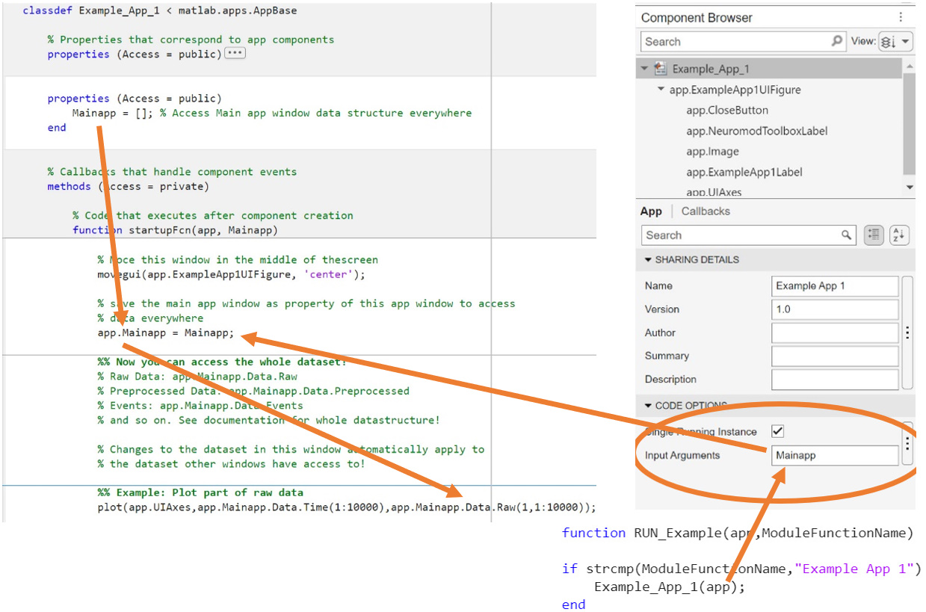

9.1. Manage Modules Window – Add you own Module:
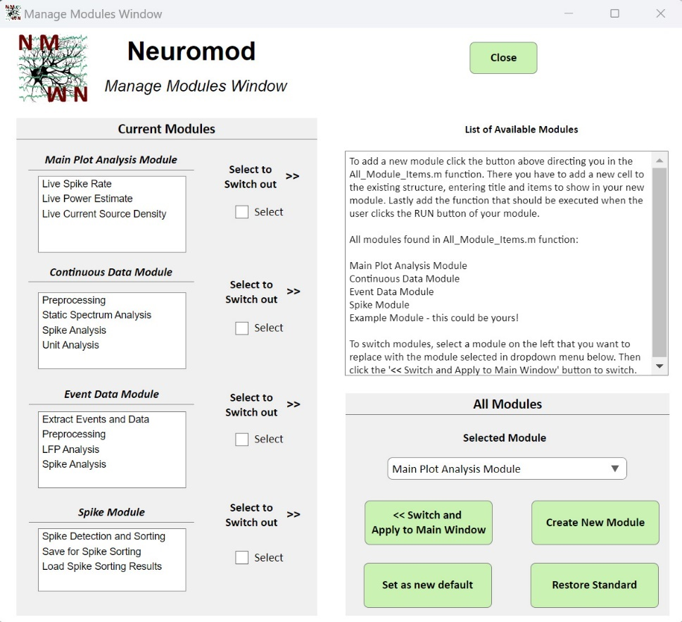
After you've done that, open the ‘Manage Modules’ window to add and activate your new module. In this window, the currently active modules are listed on the left side of the main window. On the right side, you’ll see all the modules currently added to the GUI (including the Example Module) in the ‘Selected Module’ dropdown menu. To add your new module, click the ‘Create New Module’ button. This opens a new window to specify the module information.
In this window you first need to add the title of your module (which will be displayed in the main window).
Afterwards, add the options that are shown for you module and which the user can select in the main window before clicking the RUN button of your module. For this, enter the option names after the ‘:’ in each line of the text area. If you want to show two options enter:

Module Option 1: TestOption1
Module Option 2: TestOption2
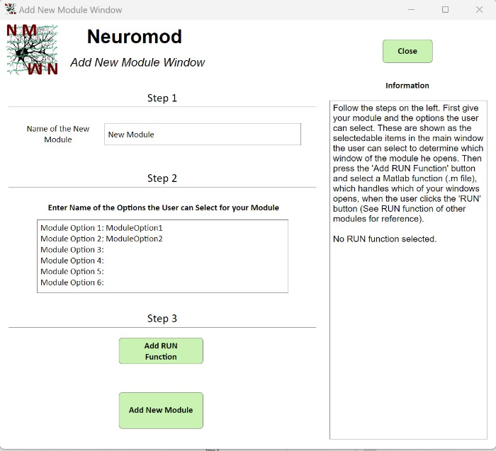
Module Option 3:
Module Option 4:
Module Option 5:
Module Option 6:

Now click the ‘Add RUN Function’ button. Select a Matlab function (.m file) that is executed when the user clicks the ‘RUN’ button of your new module. It basically checks with strcmp which option the user selected and calls the respective app window. See RUN functions of other modules.

If you entered all the required information, click the ‘Add New Module’ button. This adds the new module to the list shown in the ‘Selected Module’ dropdown menu of the ‘Manage Modules Window’. This means you can select and exchange another module with it (see next section!).
What all of this does is adding a new cell to the cell array in the ‘All_Module_Items.m’ function. Each cell in this array corresponds to one module.

Module{6}.Title = 'New Module';
Module{6}.Function = 'RUN_New_Module';
Module{6}.Items{1} = 'New Window';
Module{6}.Items{2} = 'New New Window';

9.2. Manage Modules Window – Activate your own Module:
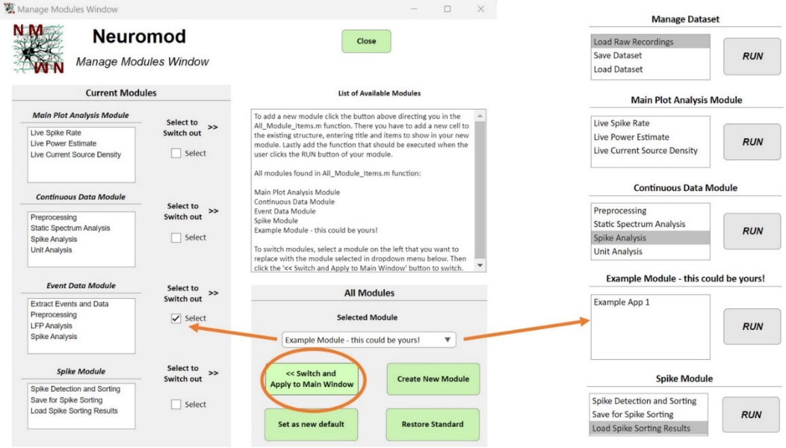
After completing the steps above, you should see your module appear in the ‘Selected Module’ dropdown menu (you may need to close and reopen the ‘Manage Modules’ window to see the changes). Now, you need to add your module to the active module selection shown in the main window on the left. This can be done by selecting the ‘Select to Switch out’ checkbox on the left. The checkbox you select there will be swapped with the module selected in the ‘Selected Module’ dropdown menu. Once you've selected both, click the ‘<<Switch and Apply to Main Window’ button. You will immediately see the change in the main window, allowing you to use your new module within the GUI.
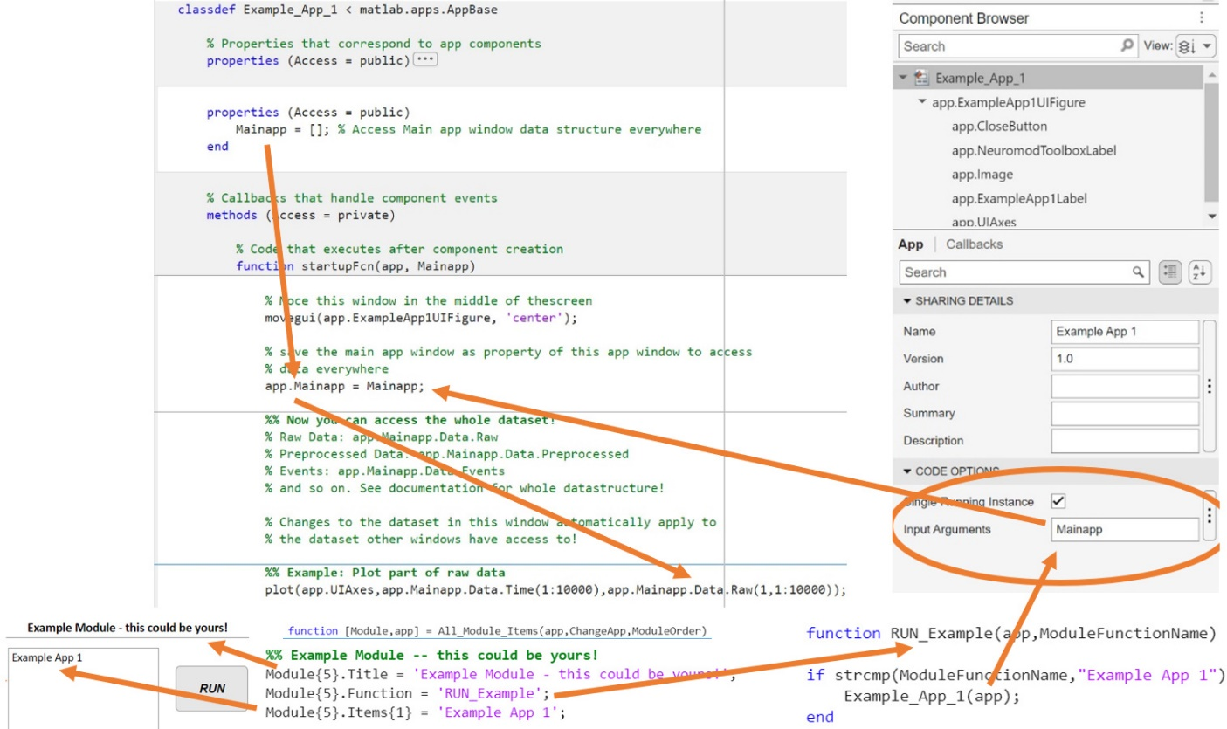
When you want to save this module change, so that you see your new module after closing and opening the GUI again, click the ‘Set as new default’ button. To restore the default module order, click the ‘Restore Standard’ button.

